Assignment_7

SalesLT.Customer.txt

Assignment 7: ADF Pipeline:
Assignment 7: ADF Pipeline 3
Easy Questions:
1. Create a pipeline named 'GetMetaData_Example' to fetch the
list of all the files available inside the ADLS folder.

2. Create a pipeline name 'Foreach_Example' to copy the
Customer & Customer address table data into ADLS using the one
copy activity.

Tough Questions:
3. Create a pipeline that first checks whether the Customer.csv file
is available in the folder location. If it is available it will copy the
file data to the Customer Table.

4. Create a pipeline that will create the incremental pipeline using
the table instead of HighWaterMark File.

5. Create a pipeline name 'Foreach_Example2' to copy the below
information using just one copy activity.
- All the product table data where productid > 100
- All the customer table data where Customer id>100 and
Customer id <1000

Solution 1:

- Create a pipeline named 'GetMetaData_Example' to fetch the list of all the files available inside the ADLS folder.

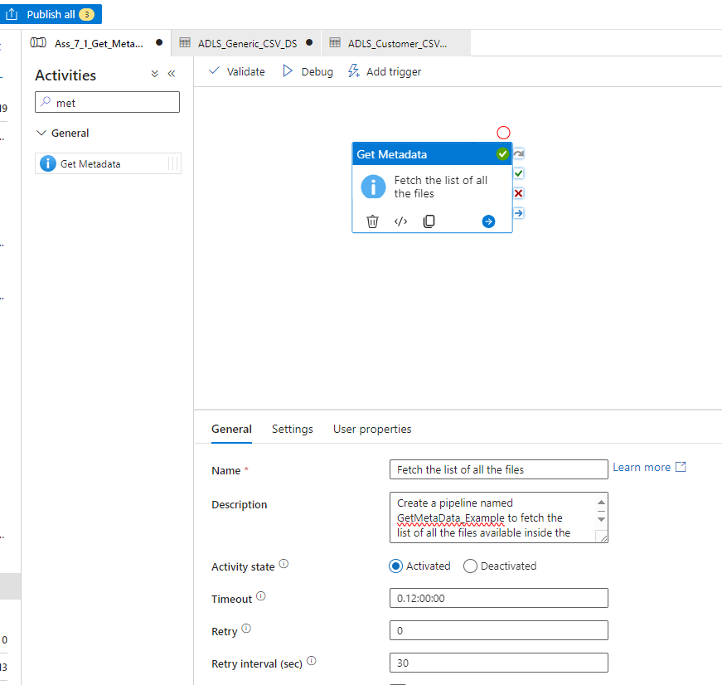

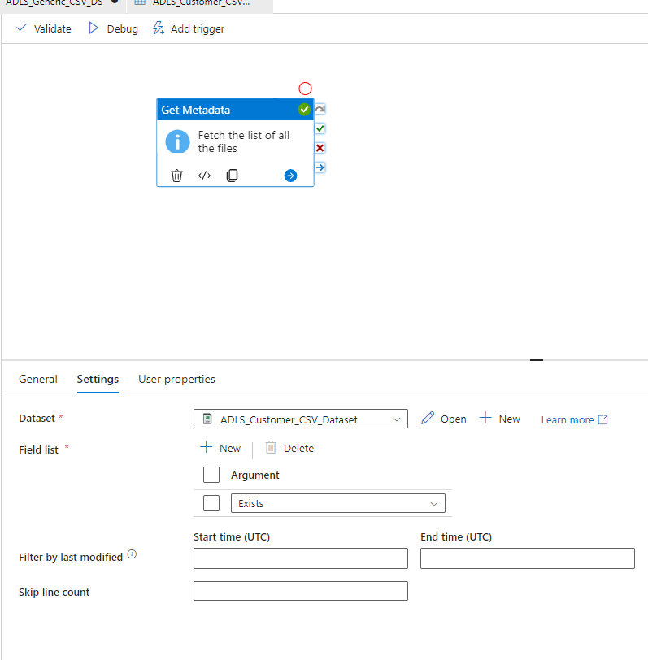

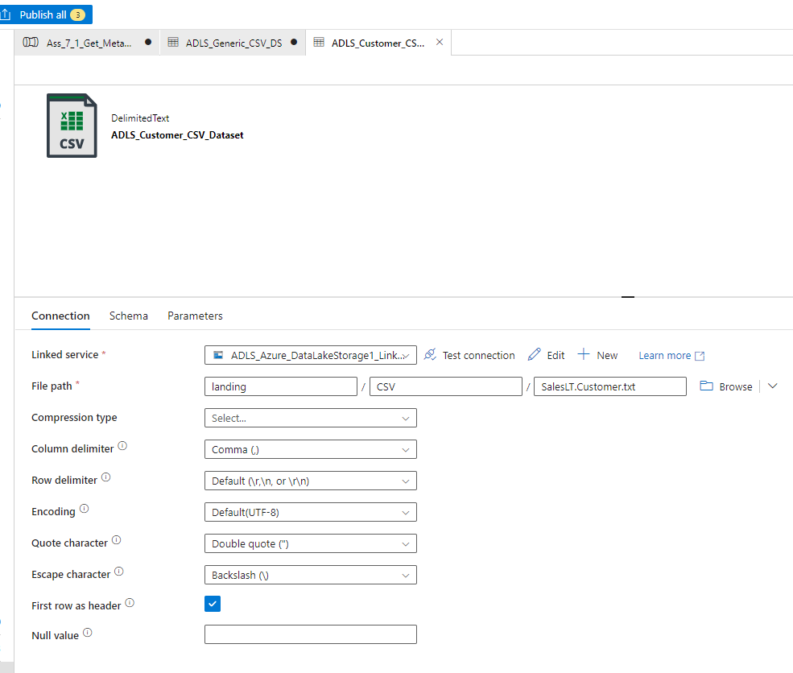
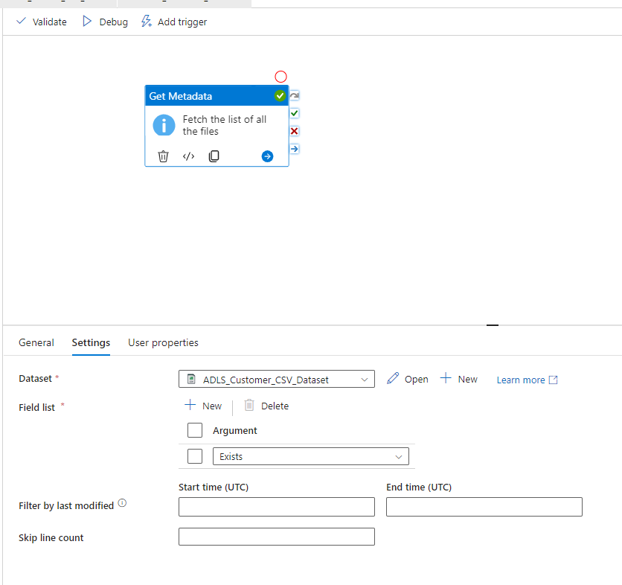

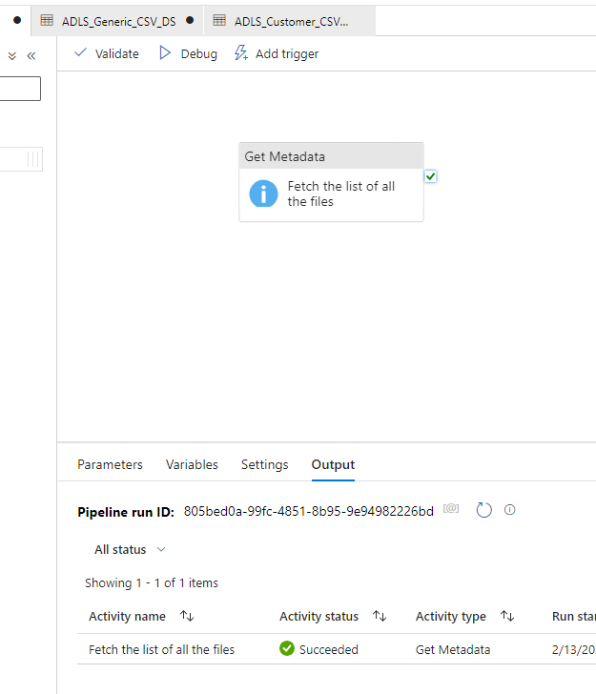

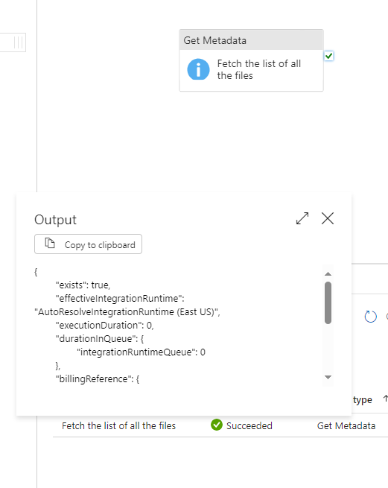

TO find all files in a folder

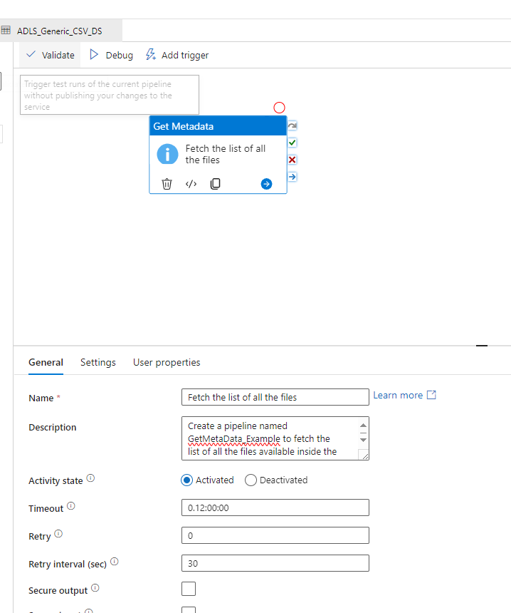

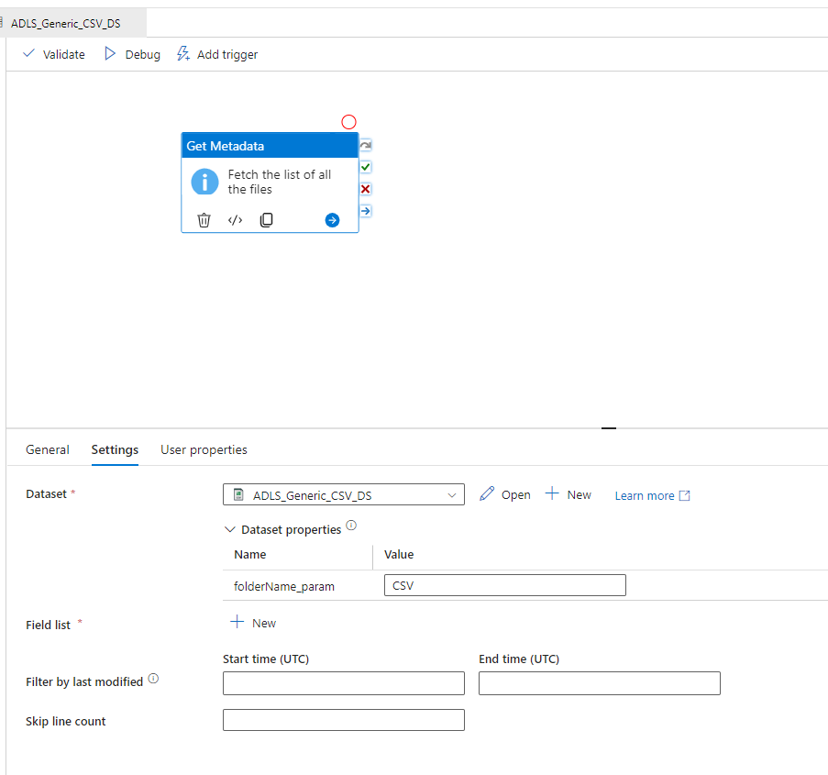

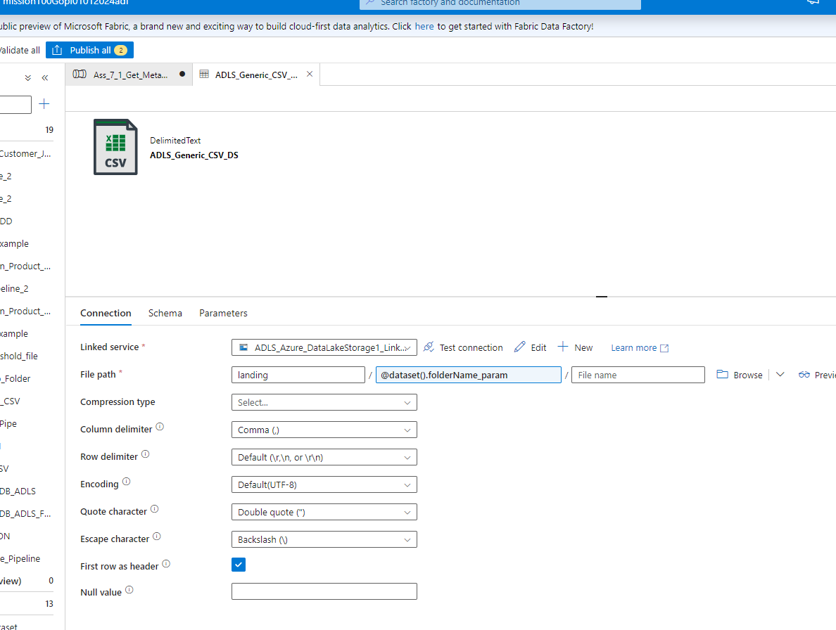

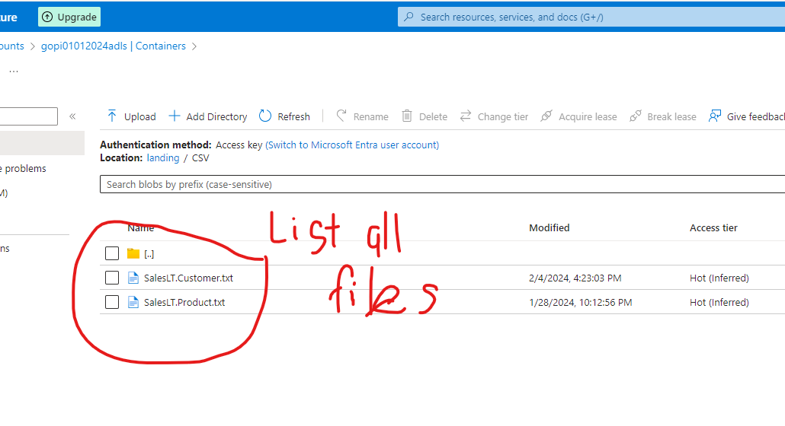

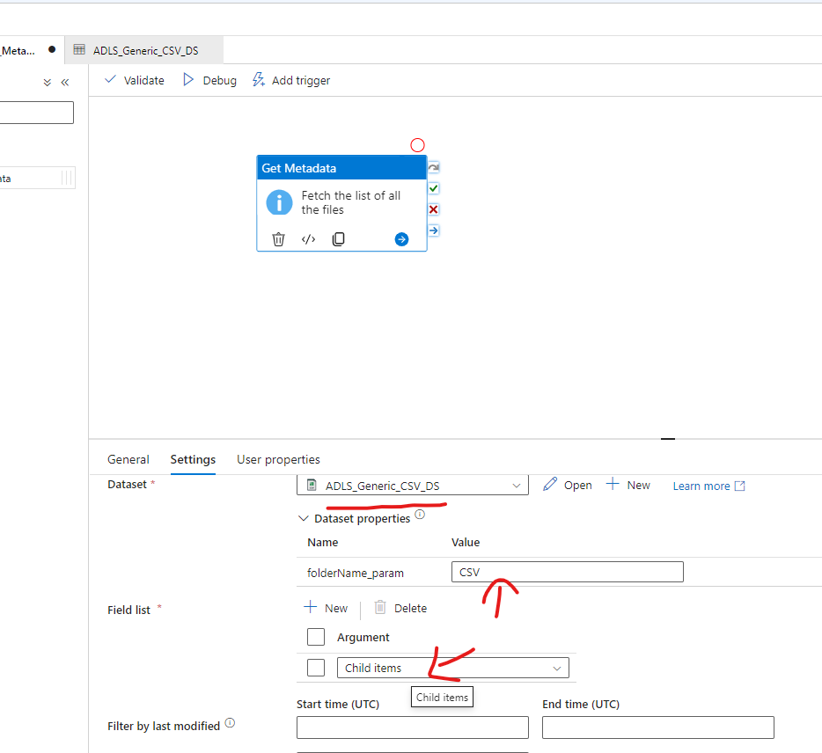

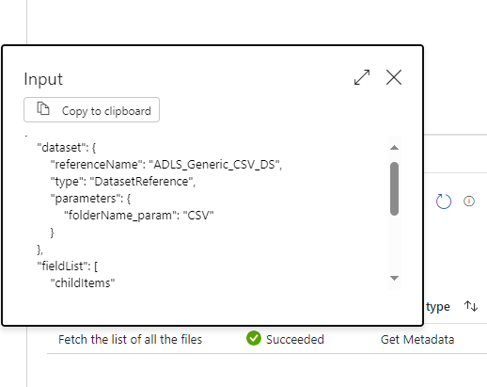

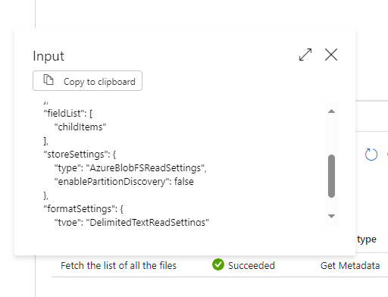
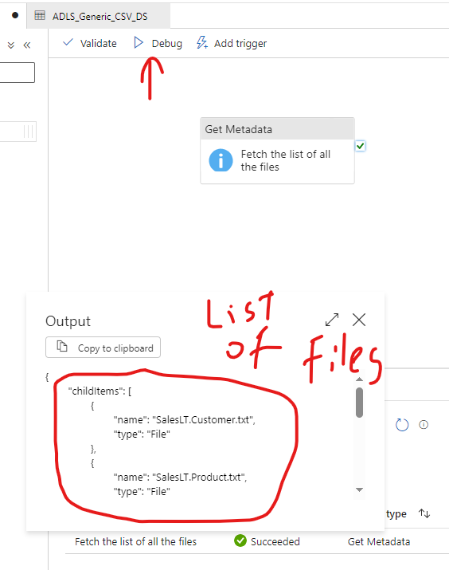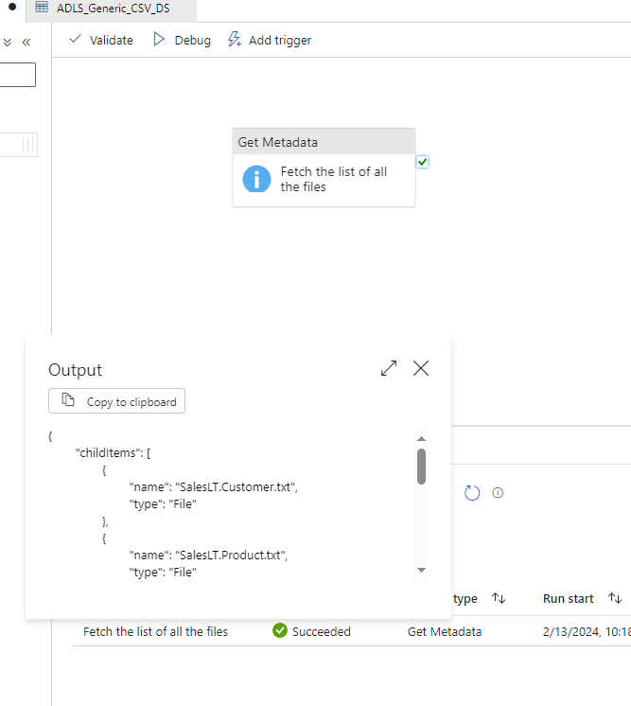

2. Create a pipeline name 'Foreach_Example' to copy the
Customer & Customer address table data into ADLS using the one
copy activity.

--- Solution Same as Assignment 6 part 2 (question 2) -- duplicate -- pelase refer it

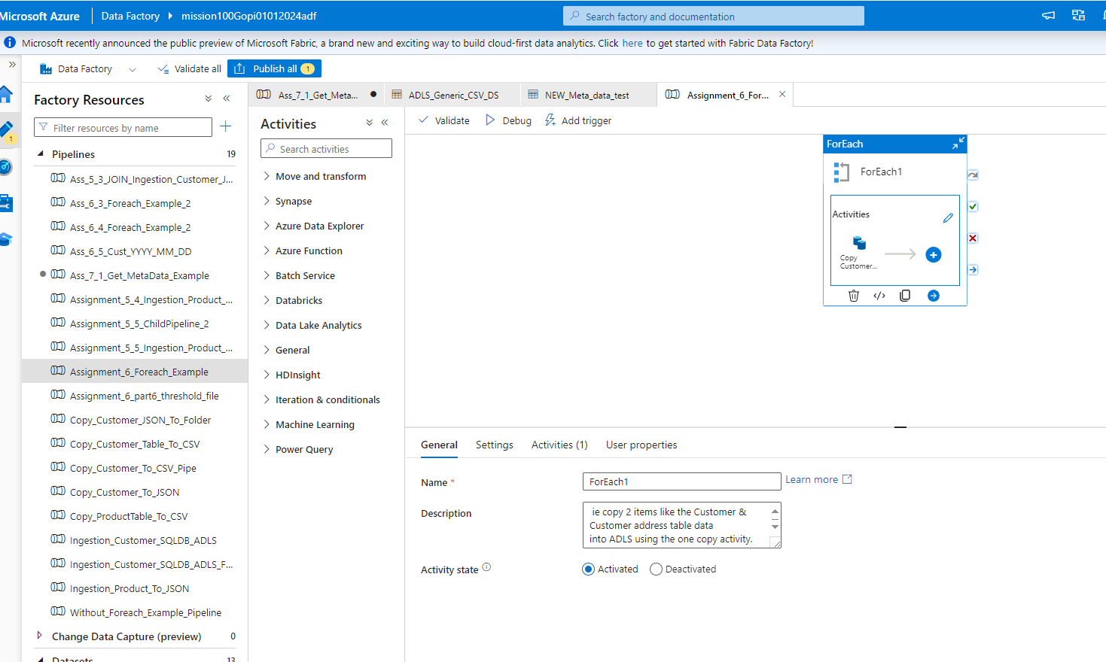

Tough Questions:
3. Create a pipeline that first checks whether the Customer.csv file
is available in the folder location. If it is available it will copy the
file data to the Customer Table.

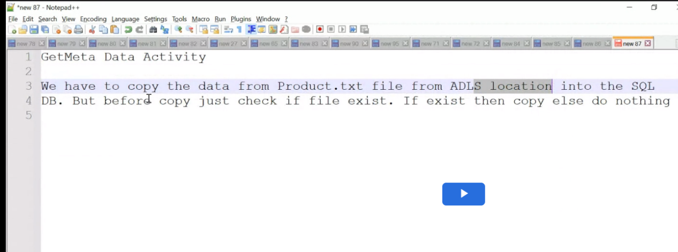

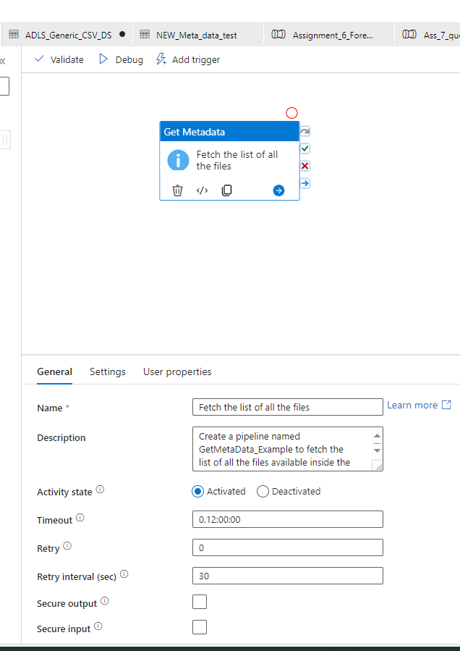
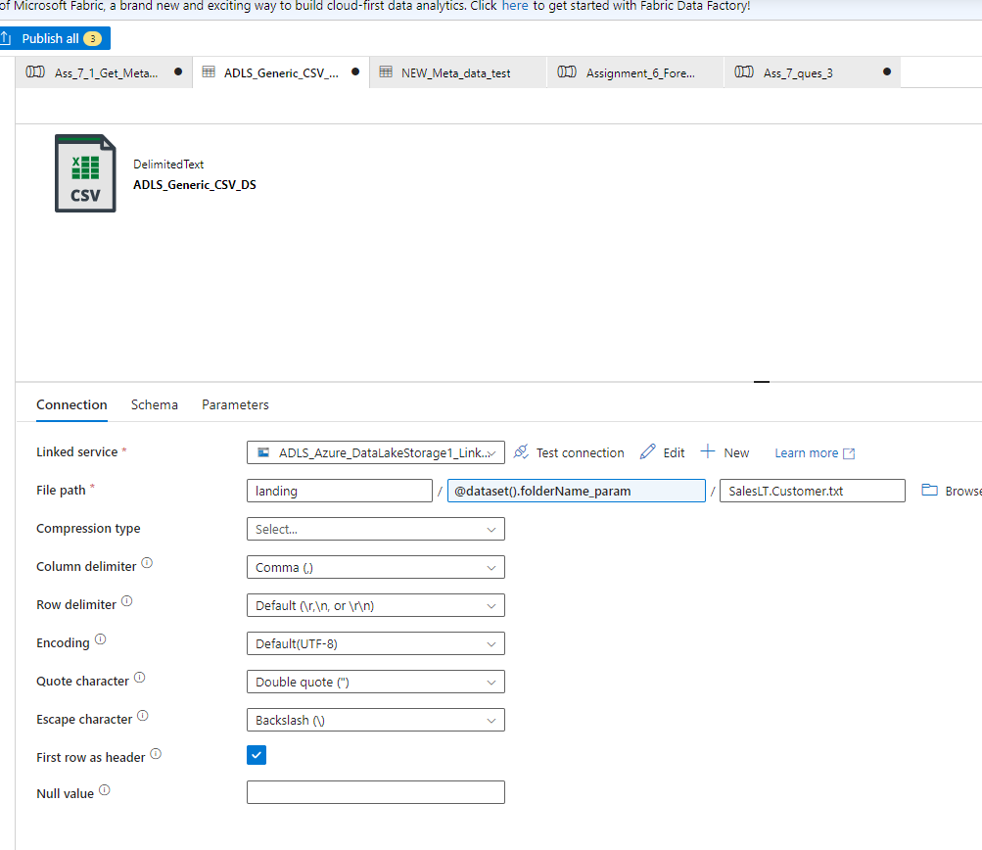

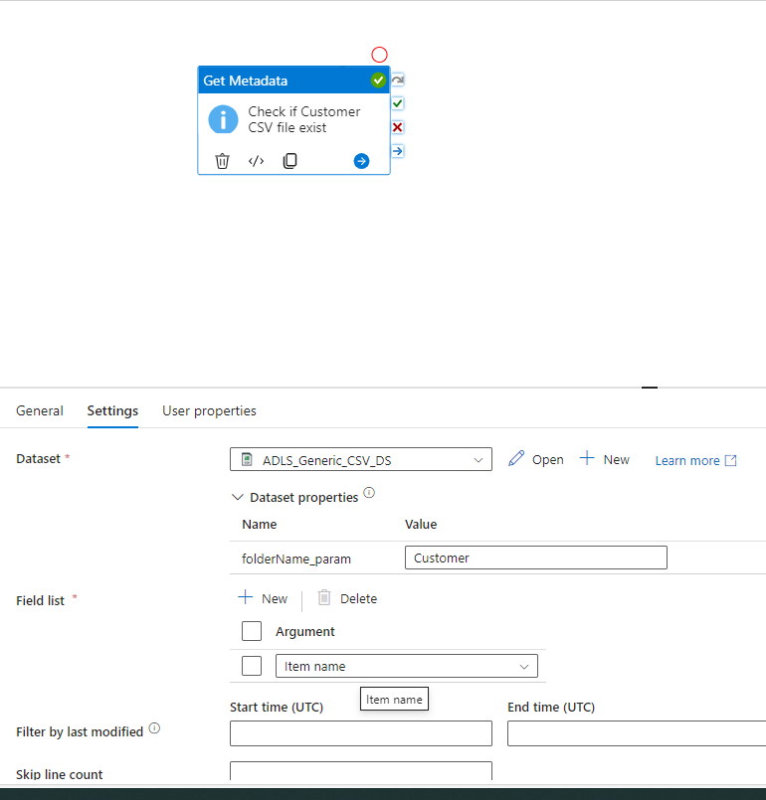

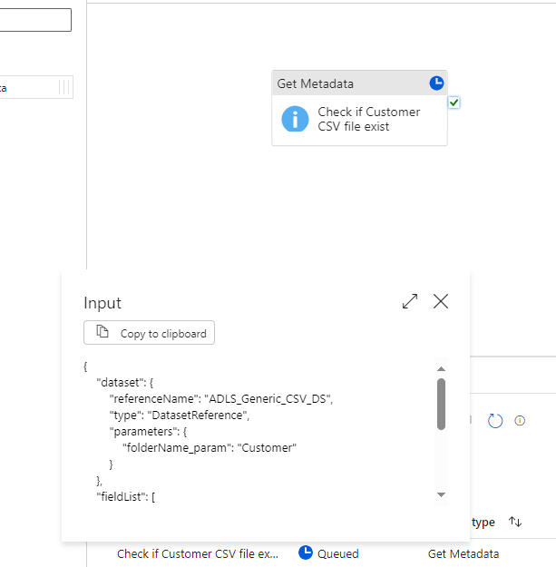

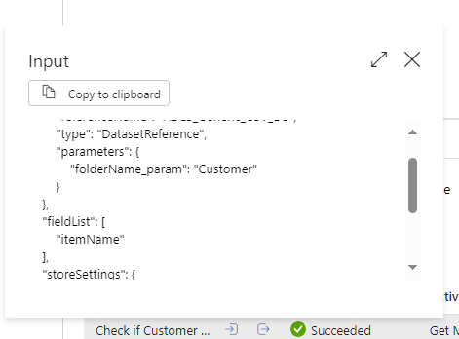

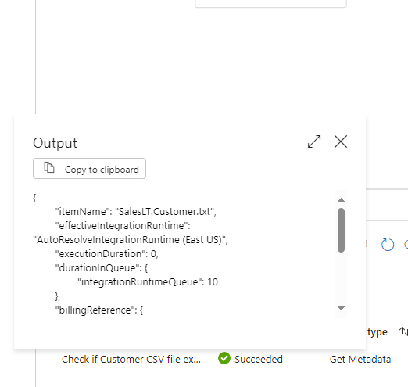

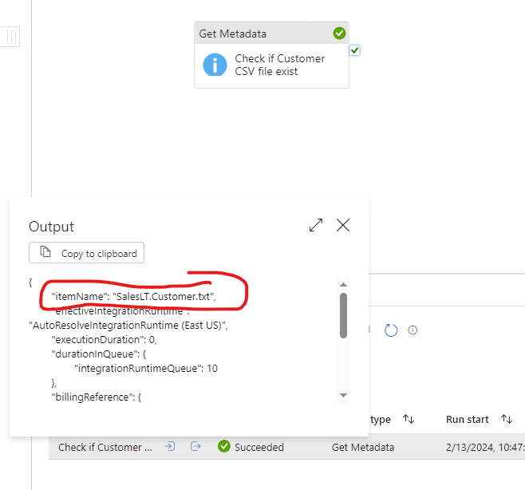

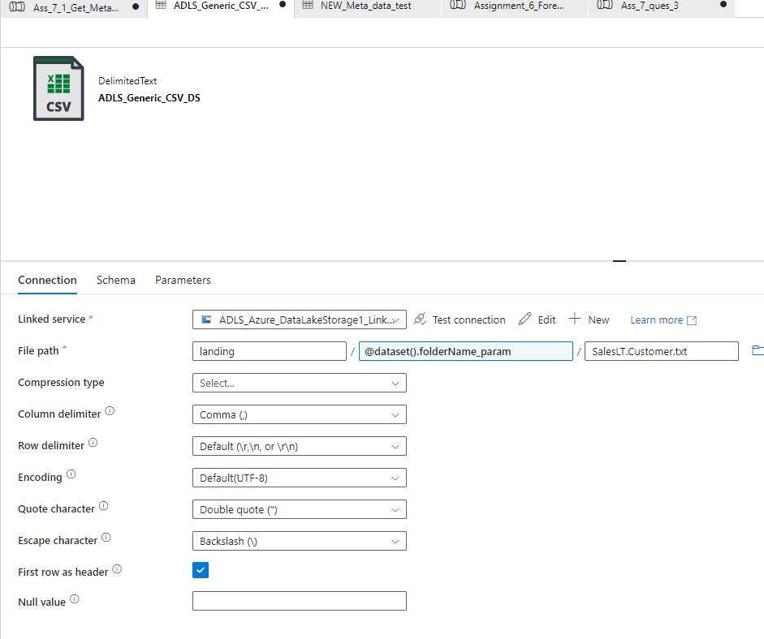

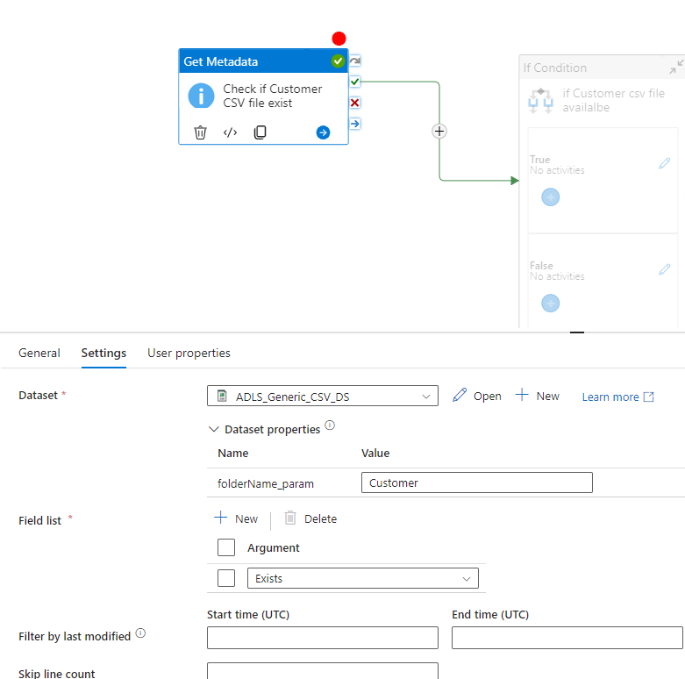

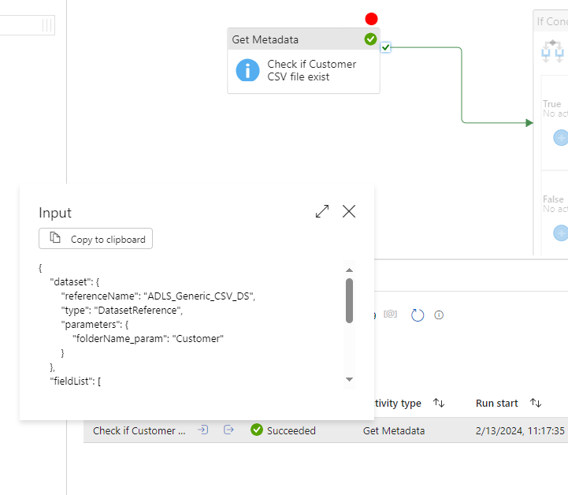

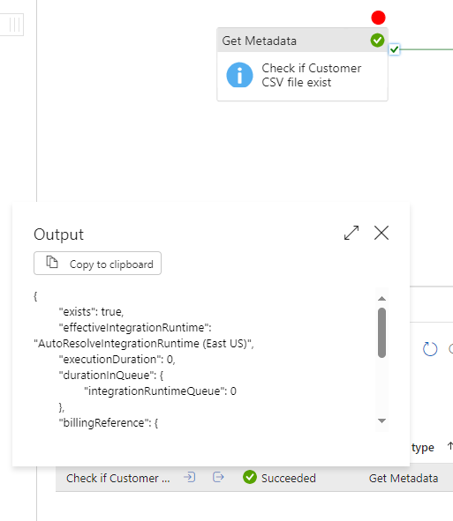

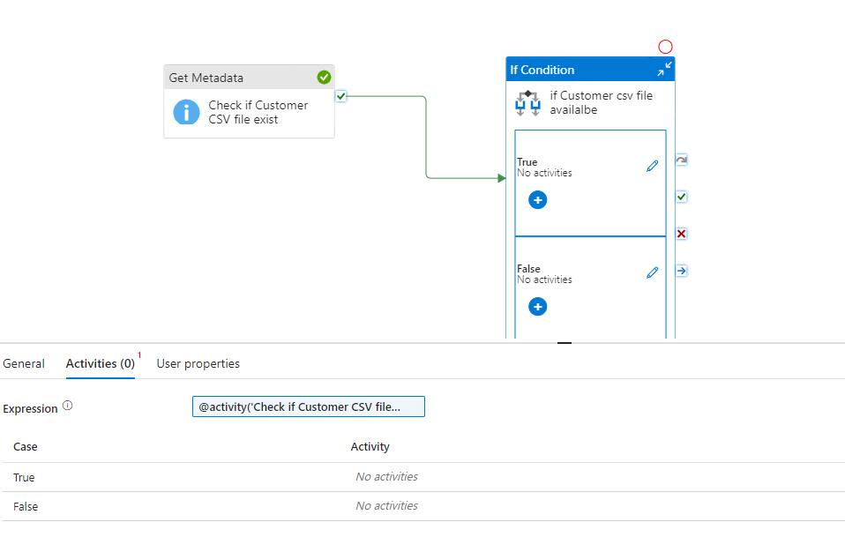

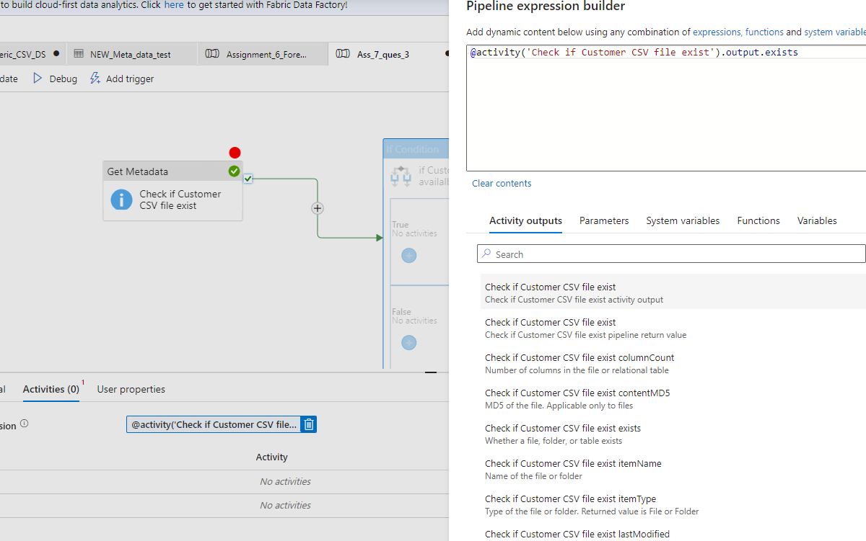

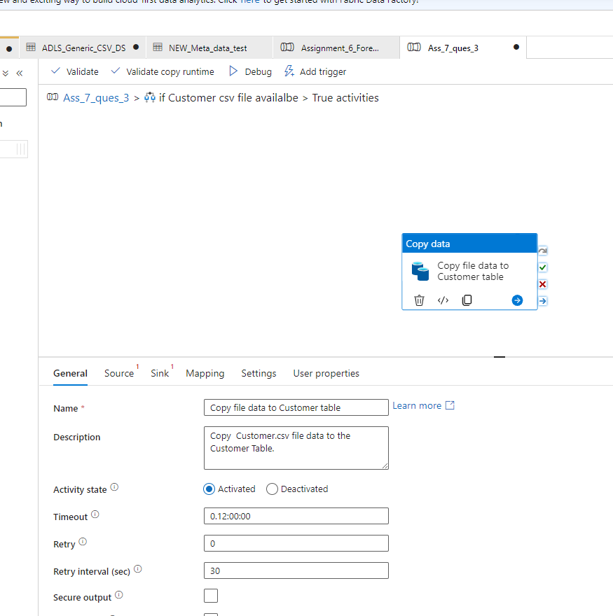

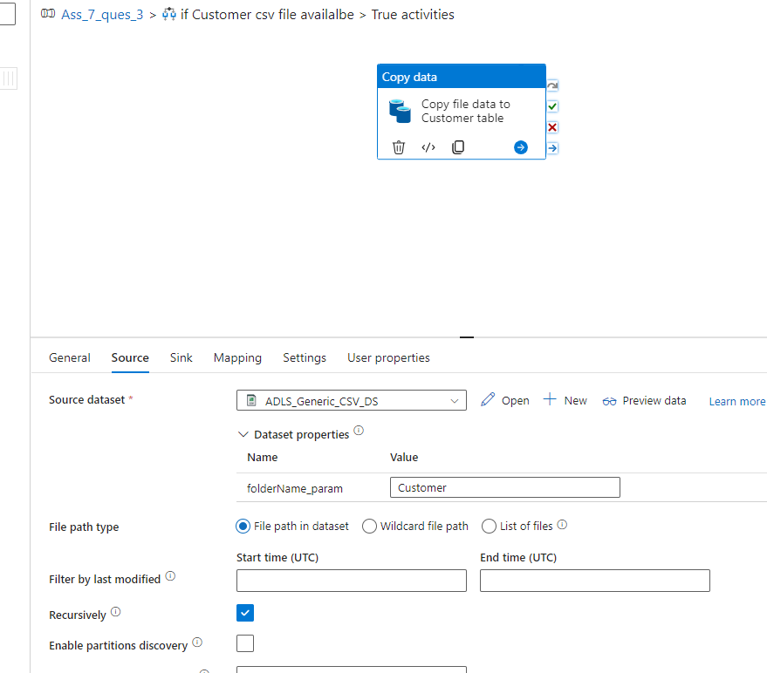

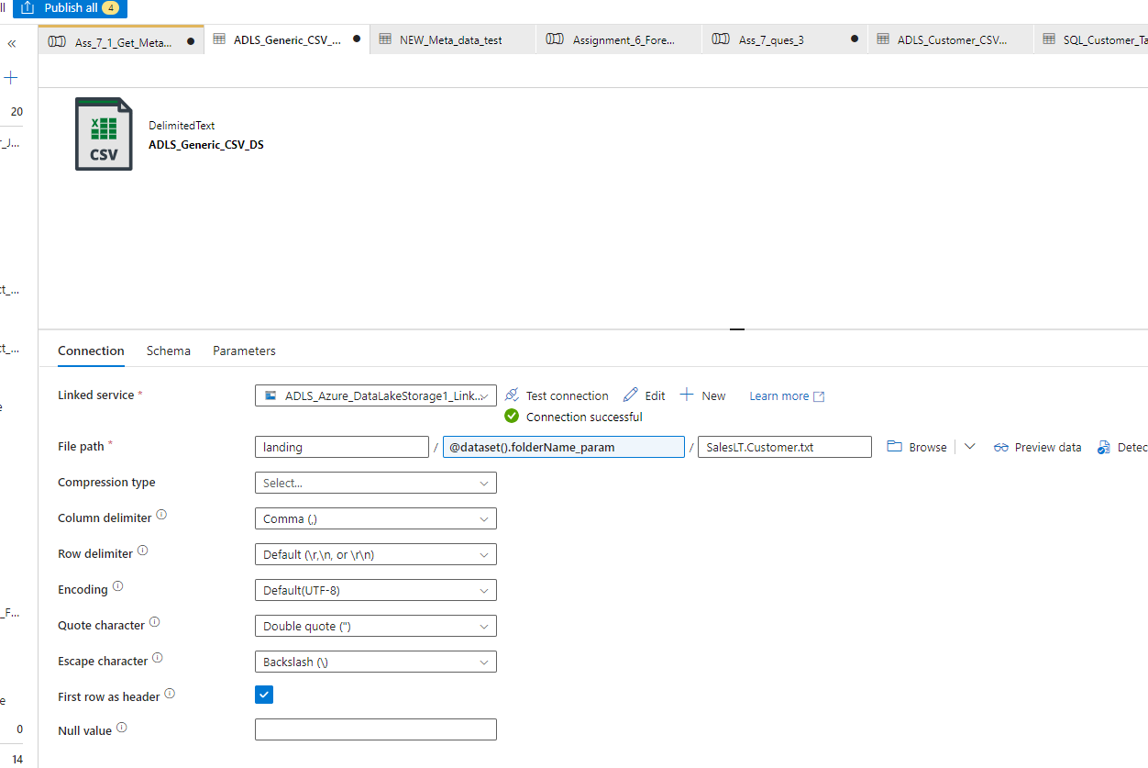
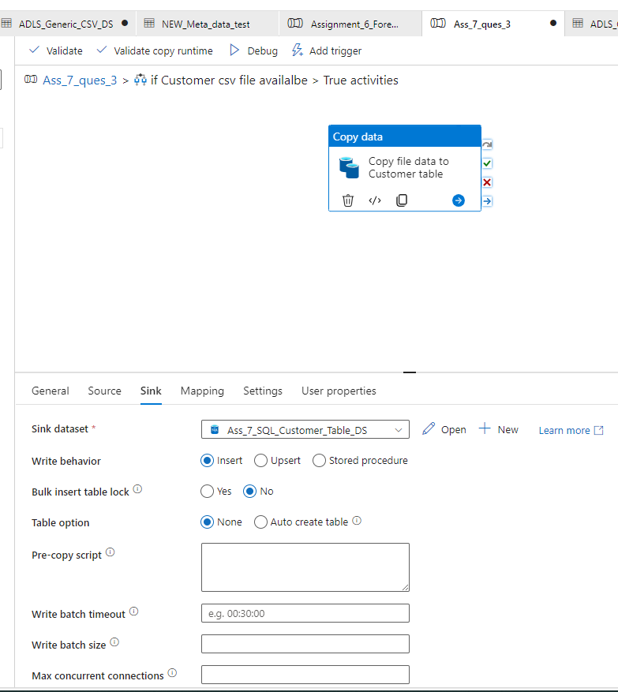

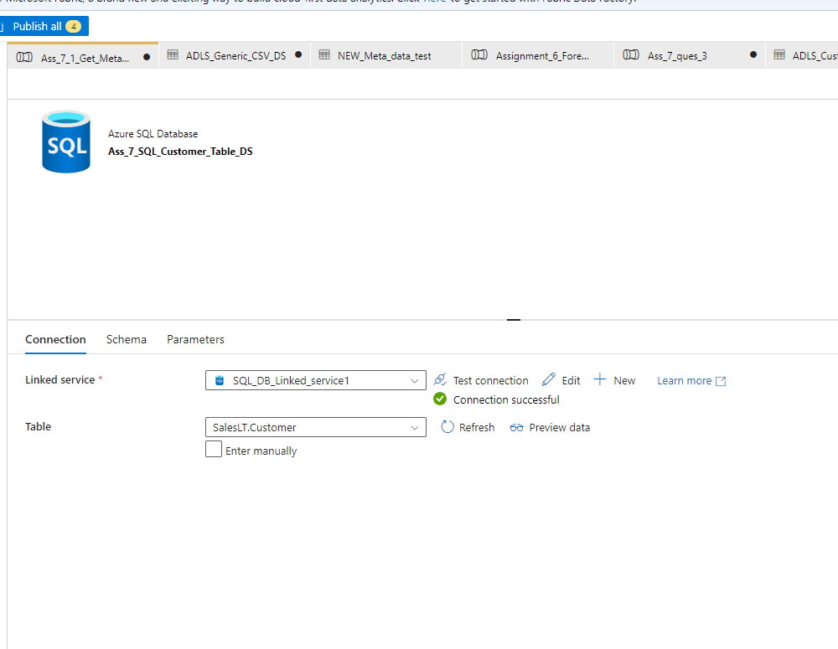

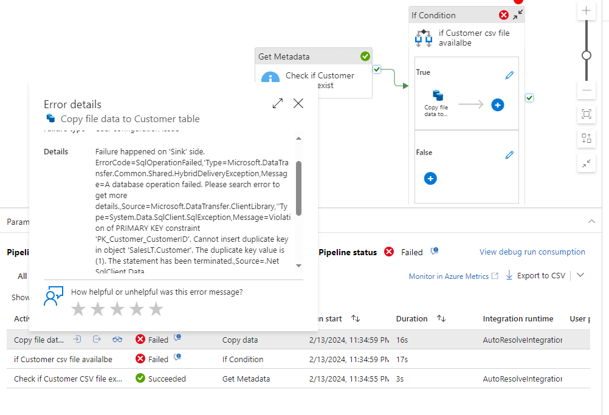

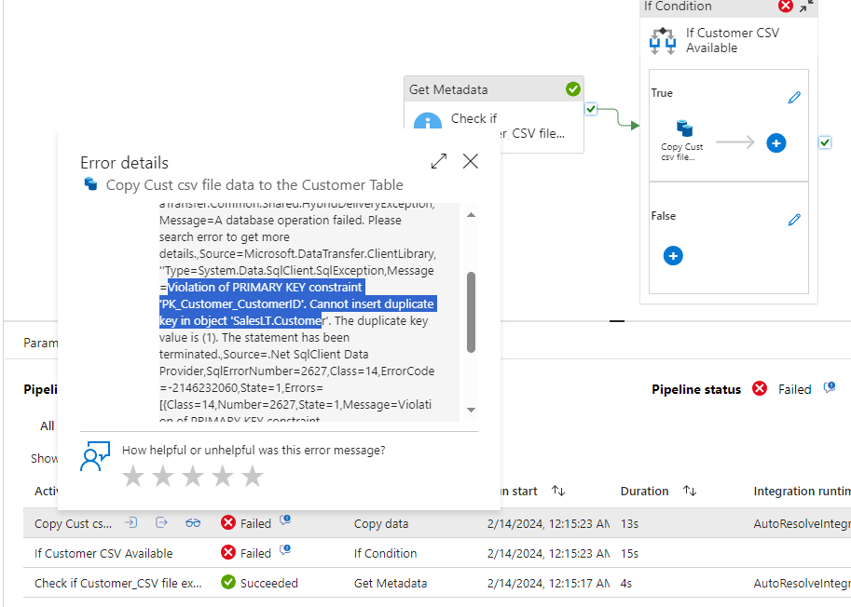

Violation of PRIMARY KEY constraint 'PK_Customer_CustomerID'. Cannot insert duplicate key in object 'SalesLT.Custome Failure happened on 'Sink' side. ErrorCode=SqlOperationFailed,'Type=Microsoft.DataTransfer.Common.Shared.HybridDeliveryException,Message=A database operation failed. Please search error to get more details.,Source=Microsoft.DataTransfer.ClientLibrary,''Type=System.Data.SqlClient.SqlException,Message=Violation of PRIMARY KEY constraint 'PK_Customer_CustomerID'. Cannot insert duplicate key in object 'SalesLT.Customer'. The duplicate key value is (1).
The statement has been terminated.,Source=.Net SqlClient Data Provider,SqlErrorNumber=2627,Class=14,ErrorCode=-2146232060,State=1,Errors=[{Class=14,Number=2627,State=1,Message=Violation of PRIMARY KEY constraint 'PK_Customer_CustomerID'. Cannot insert duplicate key in object 'SalesLT.Customer'. The duplicate key value is (1).,},{Class=0,Number=3621,State=0,Message=The statement has been terminated.,},],'

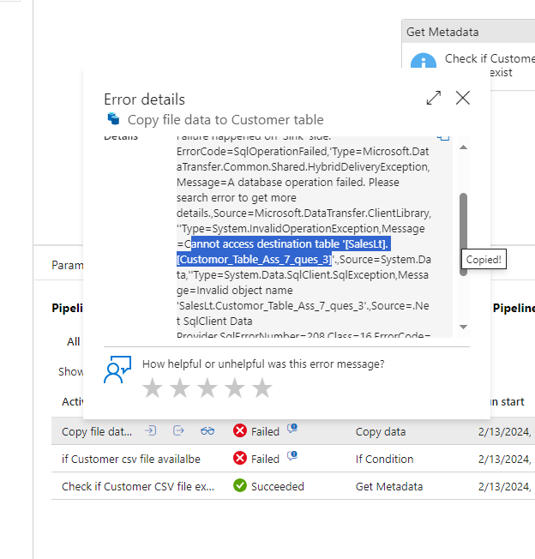

Note: Some times copy fails while trying to copy file cannot be copied from ADLS product.txt to SQL product DB.

This is because of Primary key constraints in the SQL DB,

Because Customer Table already exists, so if you try to insert same duplicate value, Primary key throws error becaseu of duplication

Soltuion: Create a new Table name Customer copy_table or Truncate existing record OR upsert

You can refer assignemnt 6_question 3 solution

I used the approach of Upsert (Update + Insert) Based on one of the column field, I choose CustomerID

Alternatively, you can create a new SQL DB table and insert /copy your records

CREATE TABLE TsInfo ( EmpId INT IDENTITY PRIMARY KEY, EmpName NVARCHAR(128) NOT NULL, Email NVARCHAR(256) )

How To Create Table In Azure SQL Database - Azure Lessons

On the Query window, write the query below.
CREATE TABLE Student
(
StudentId INT IDENTITY PRIMARY KEY,
FirstName NVARCHAR(128) NOT NULL,
LastName NVARCHAR(128) NOT NULL,
DateOfBirth DATE NOT NULL
)

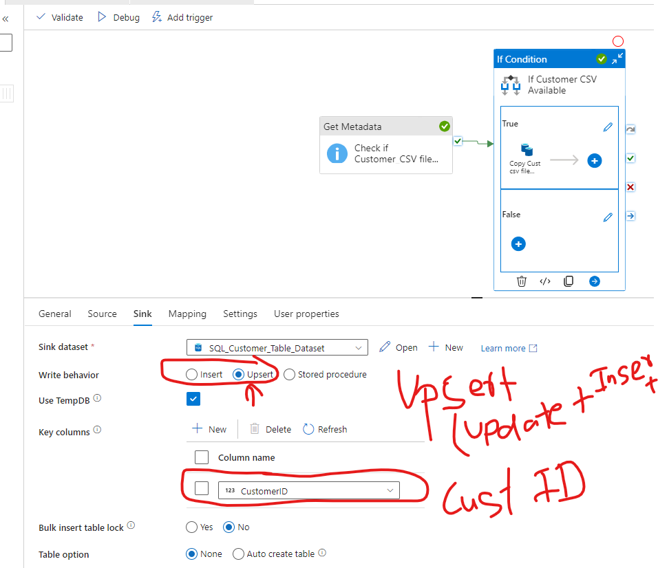

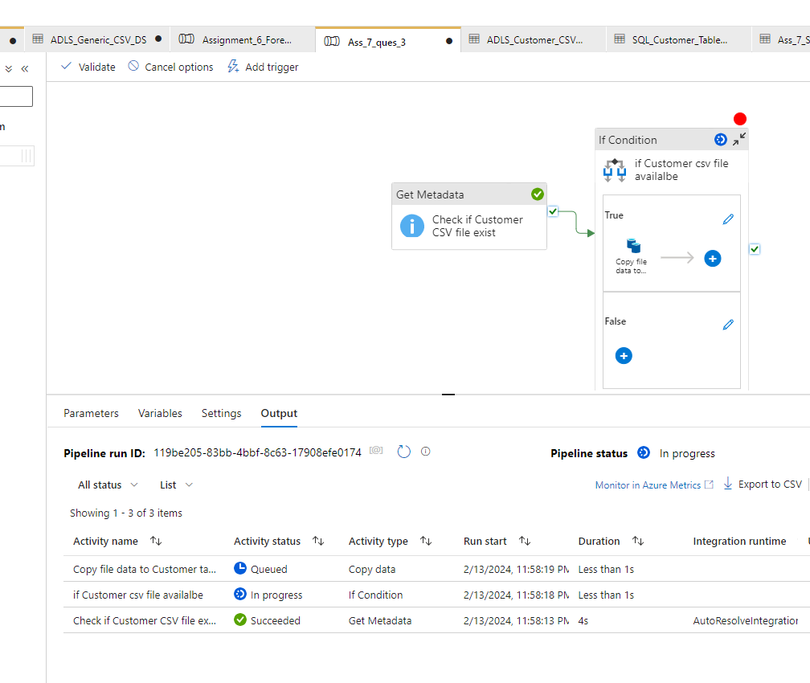

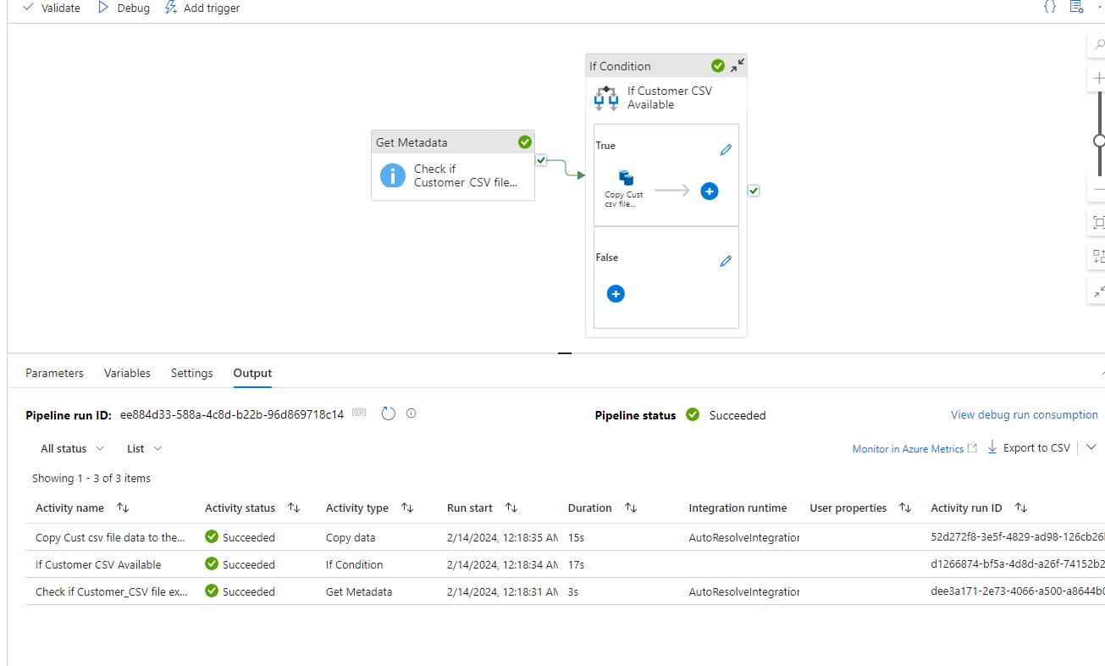

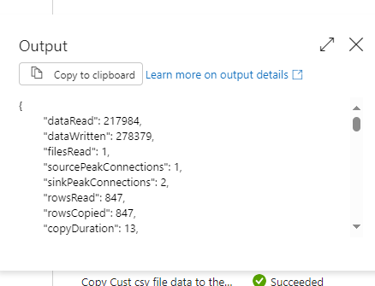
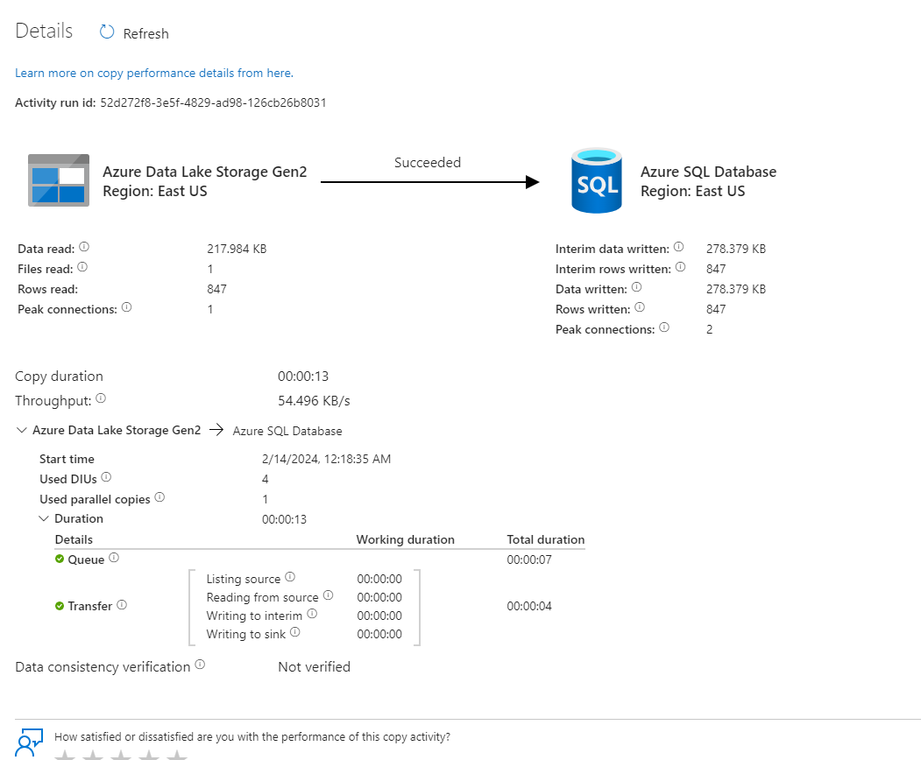

5. Create a pipeline name 'Foreach_Example2' to copy the below
information using just one copy activity.
- All the product table data where productid > 100
- All the customer table data where Customer id>100 and
Customer id <1000

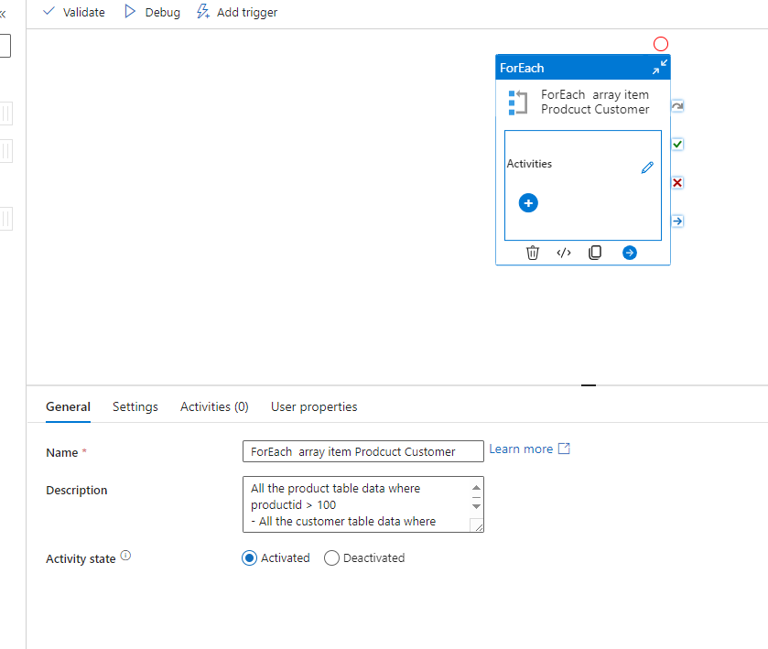

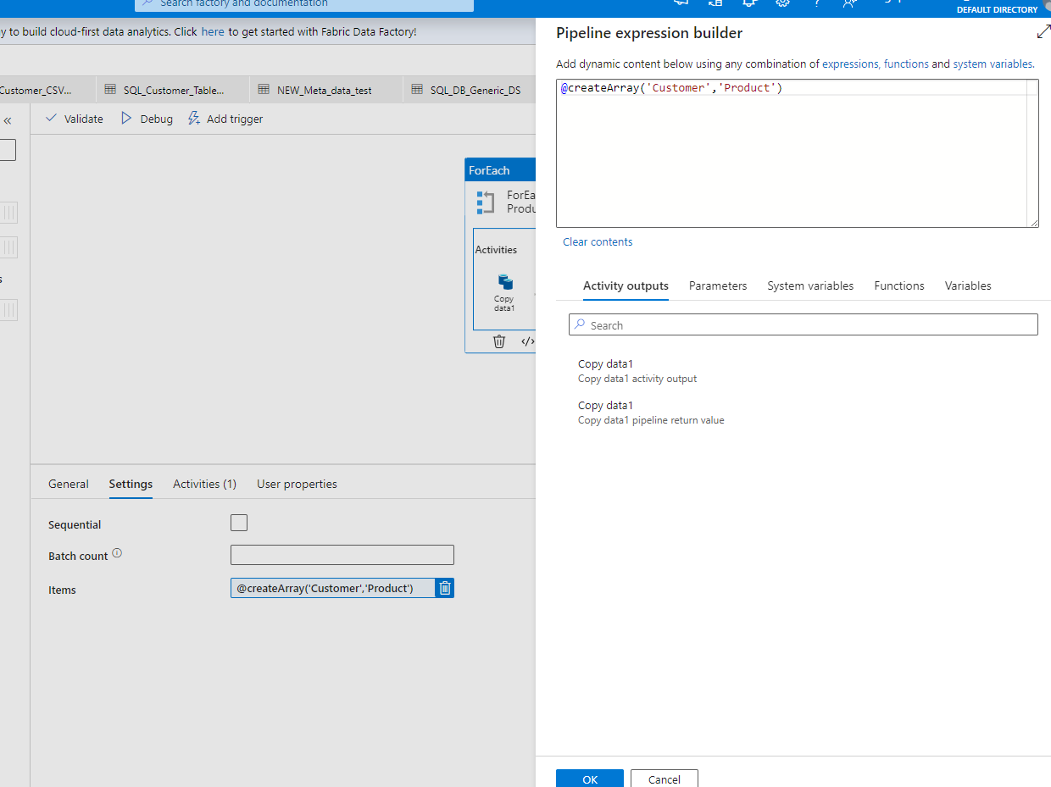

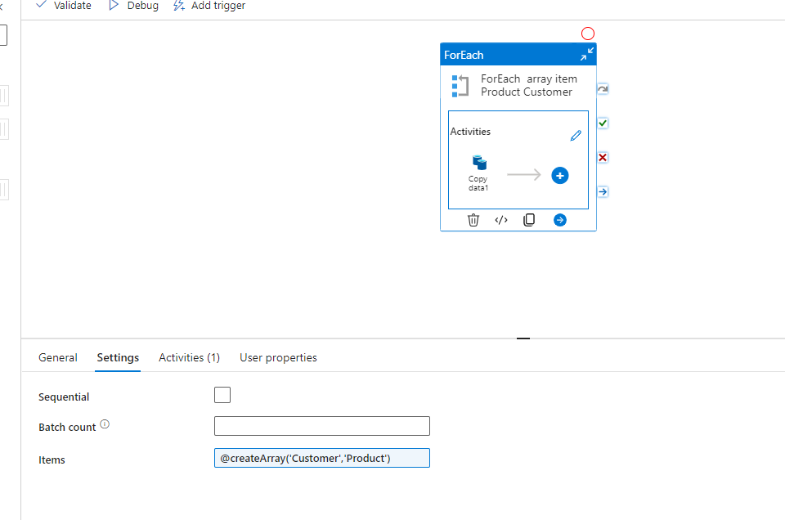

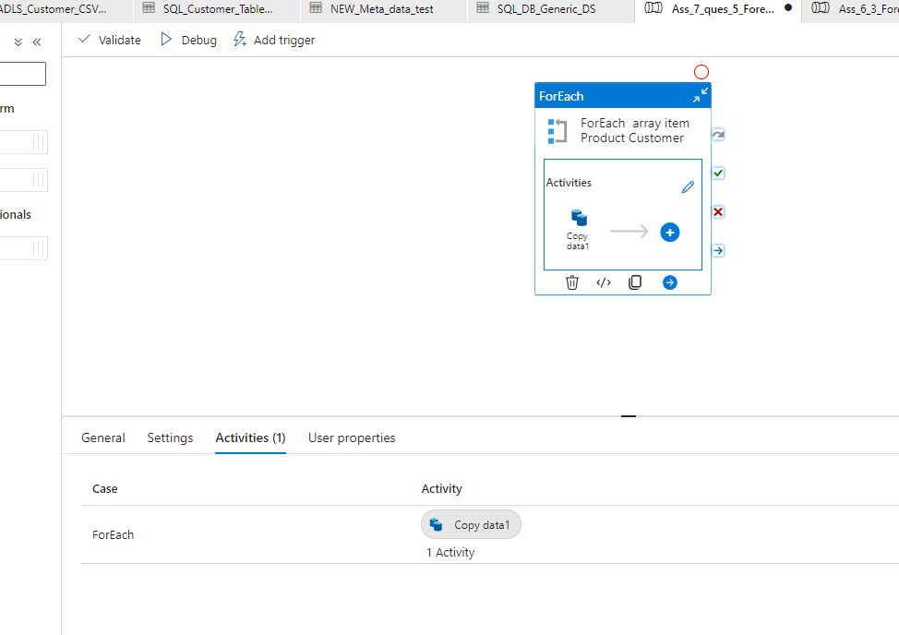

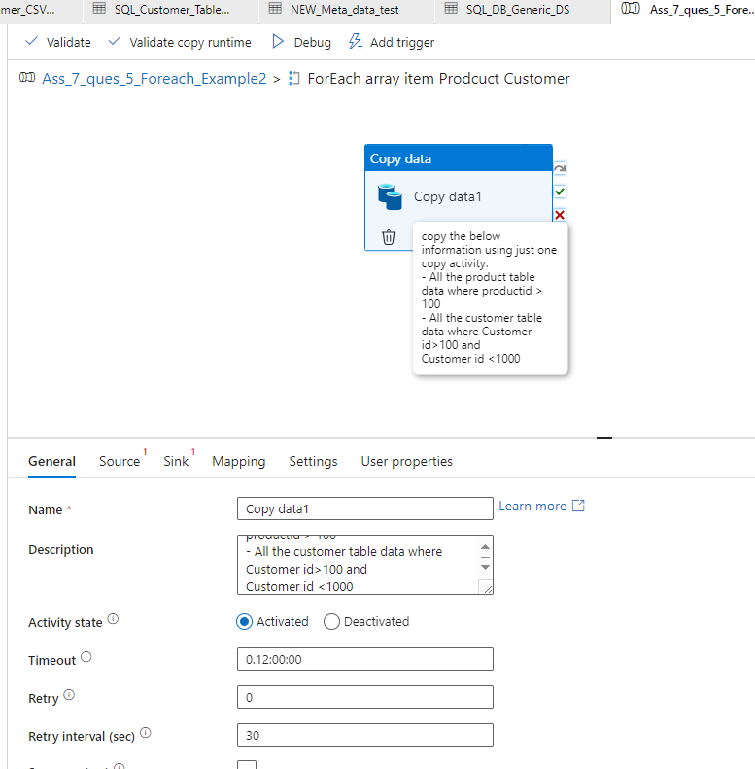

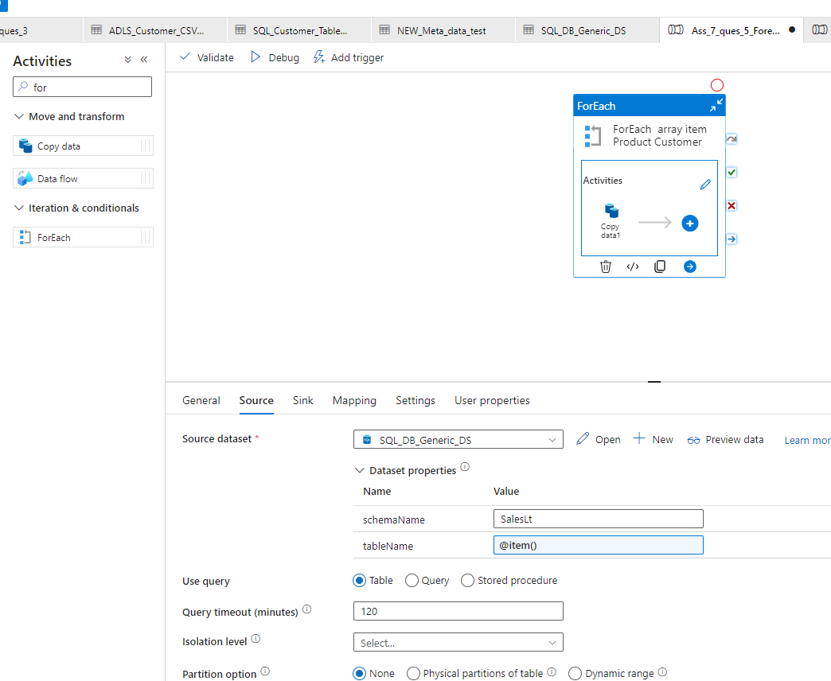

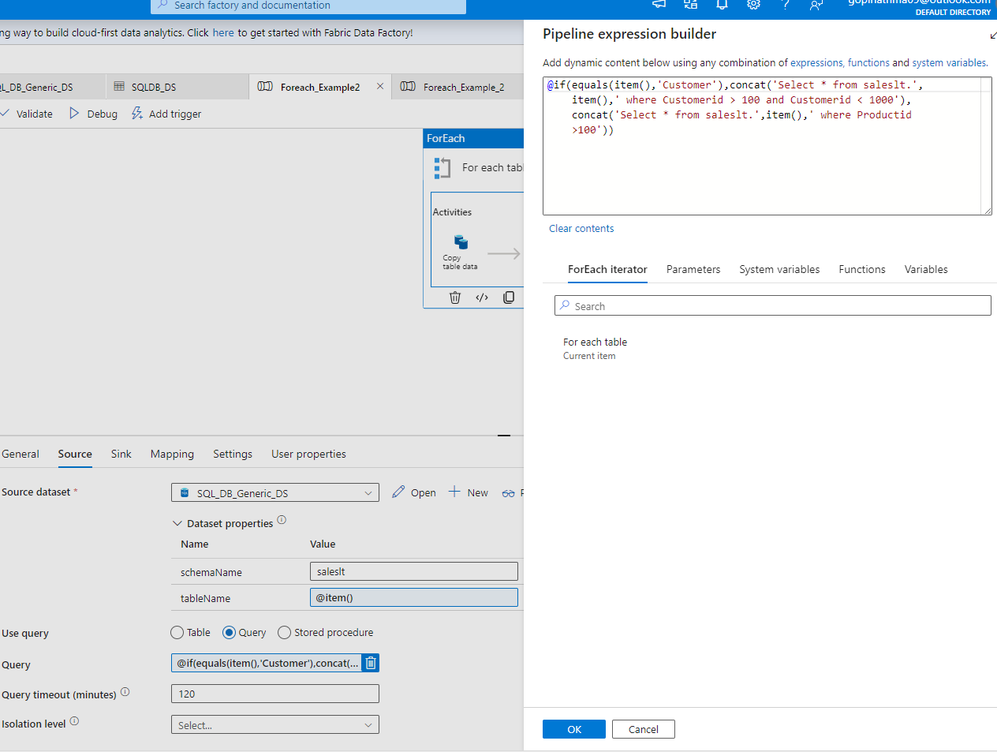
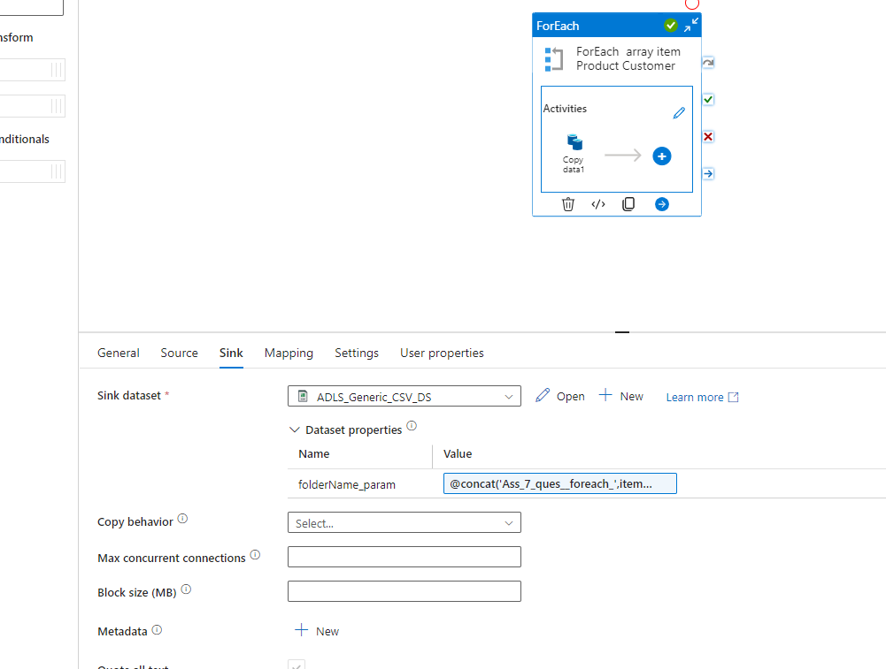

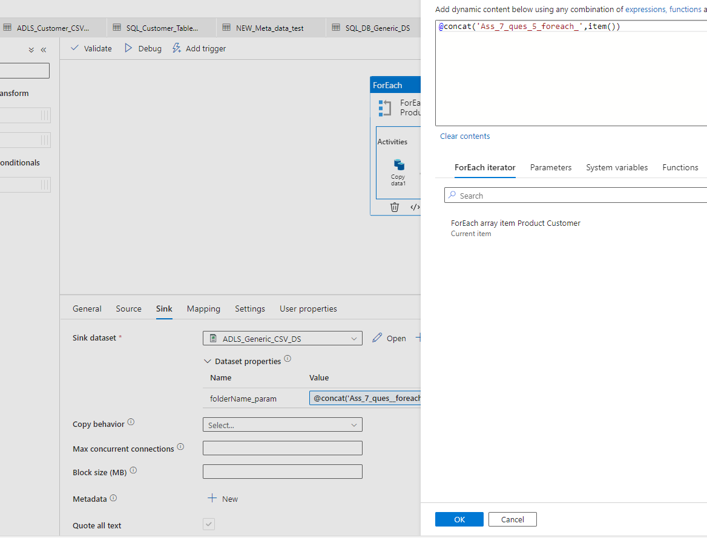

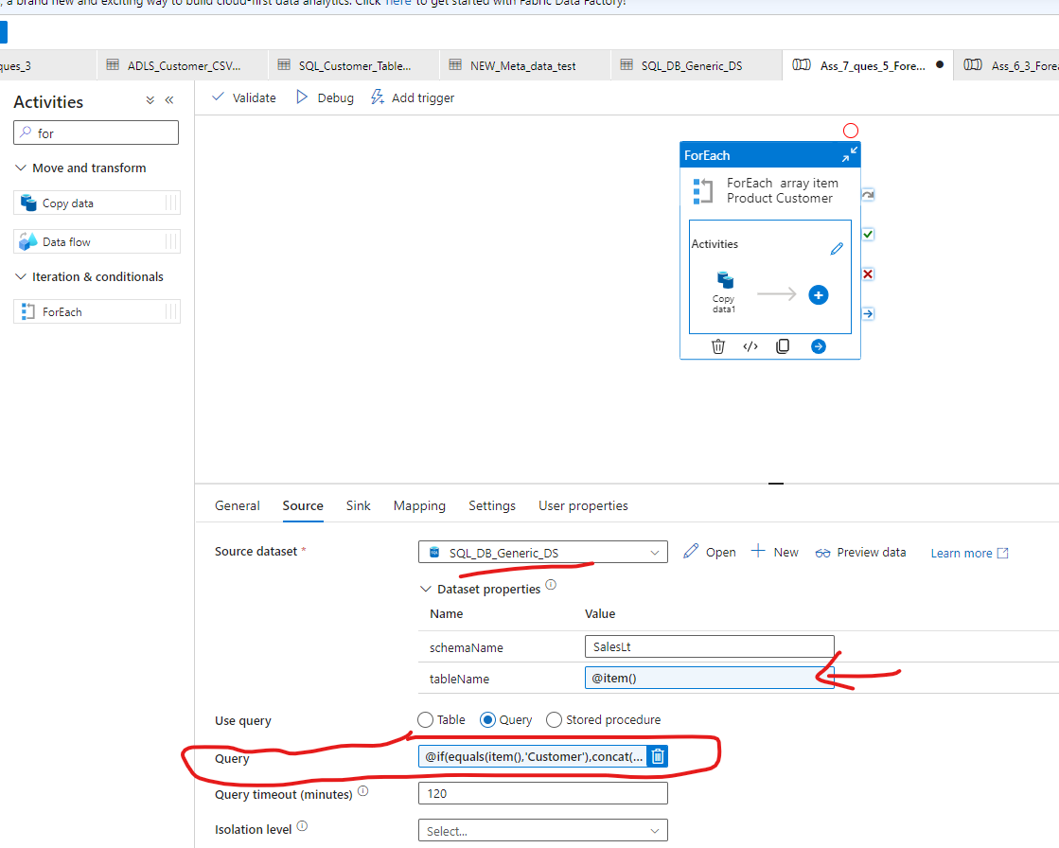

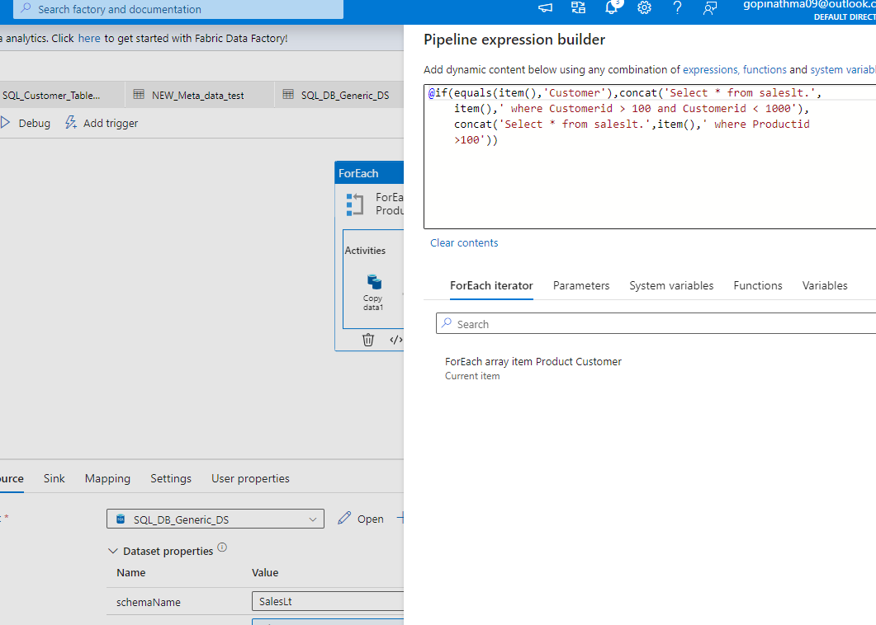

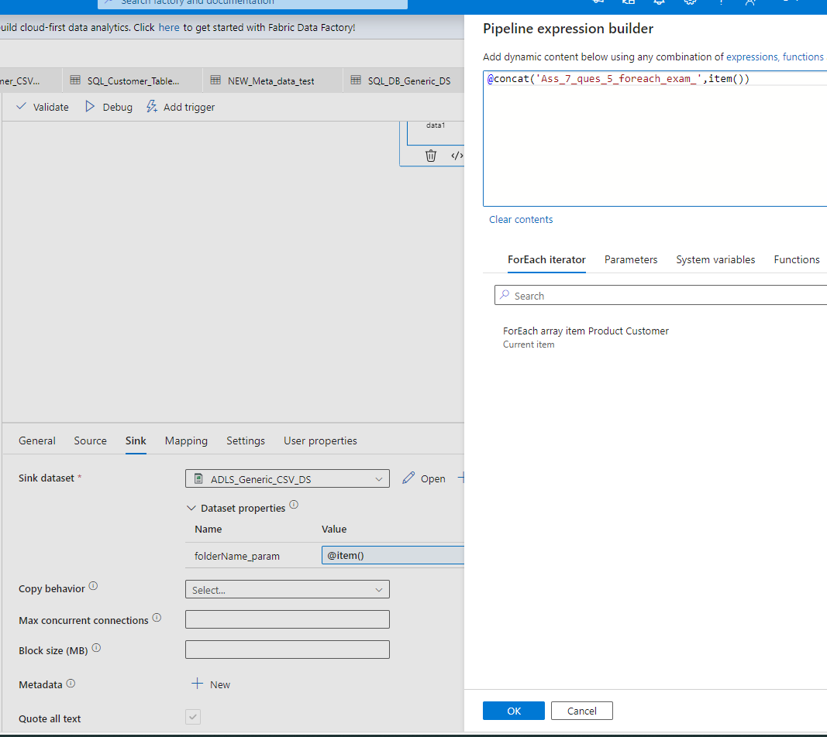

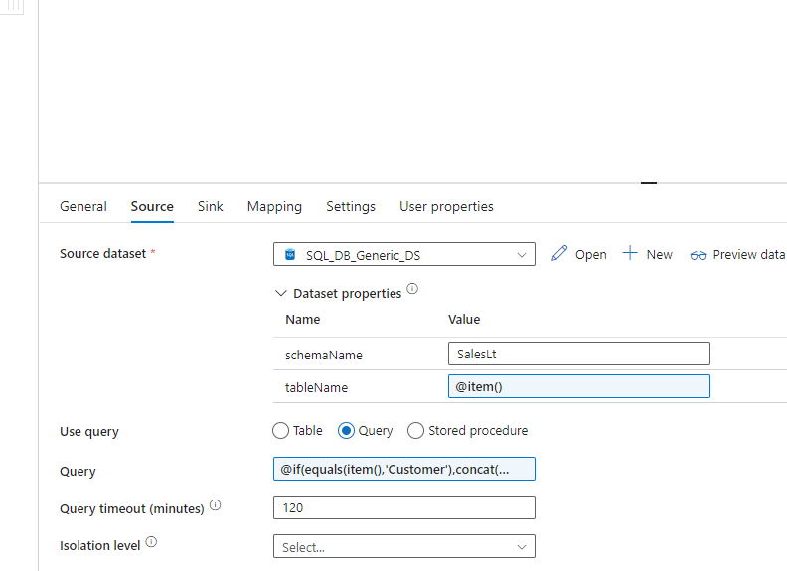

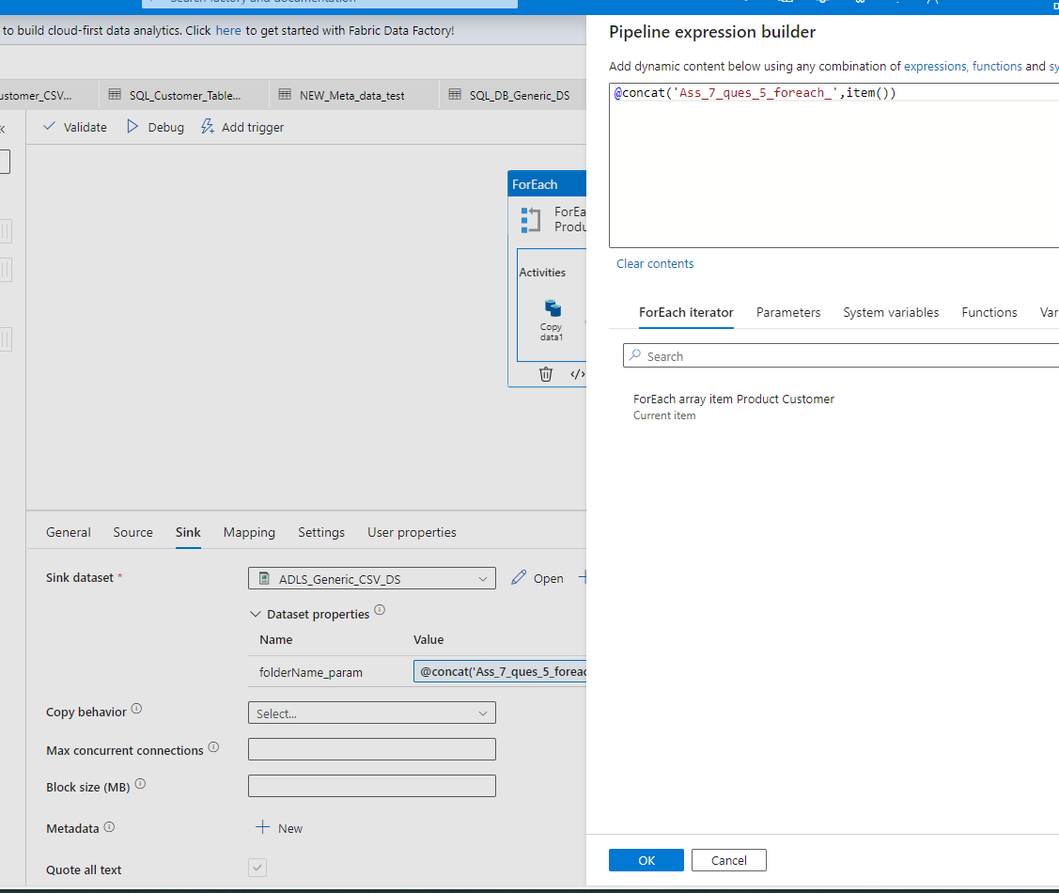

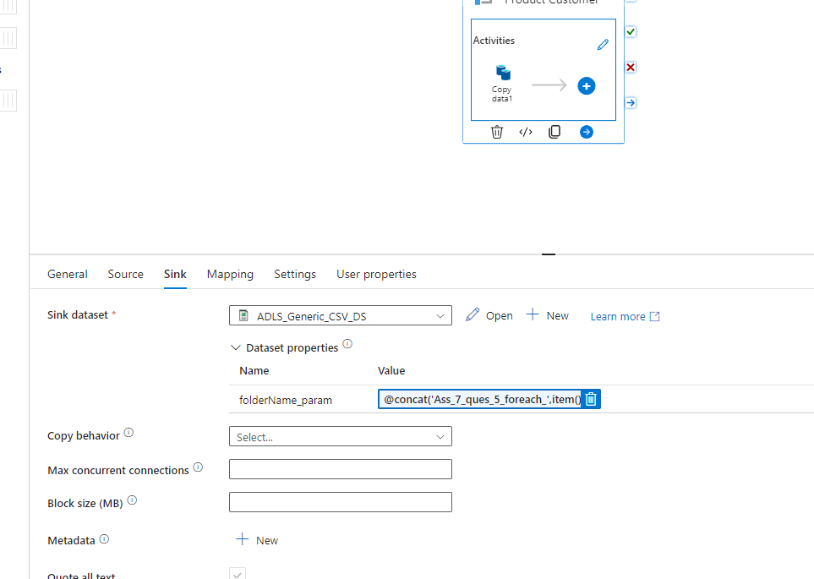

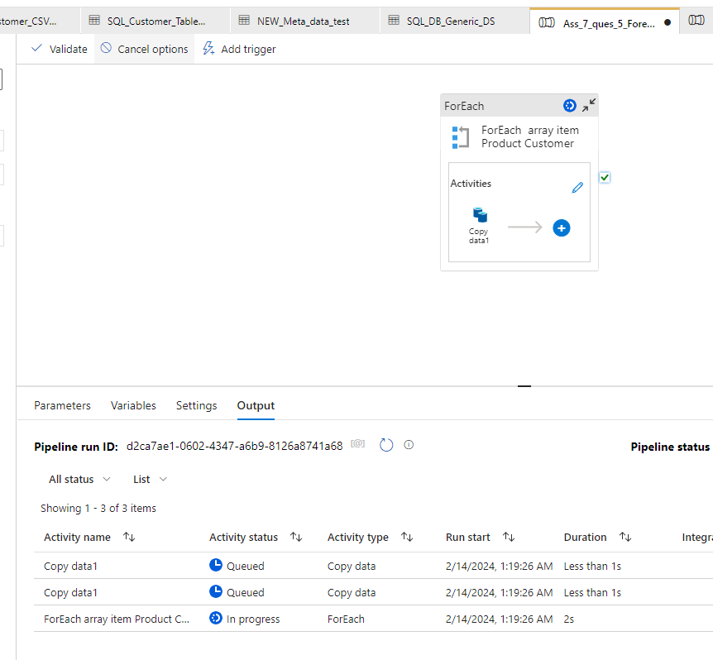

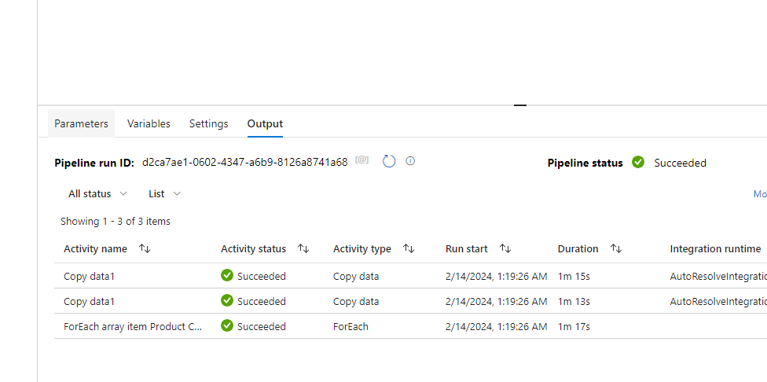

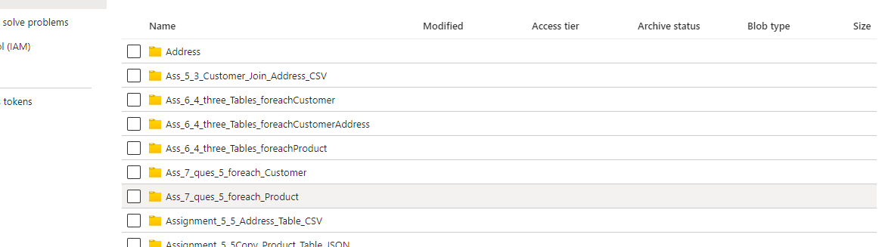

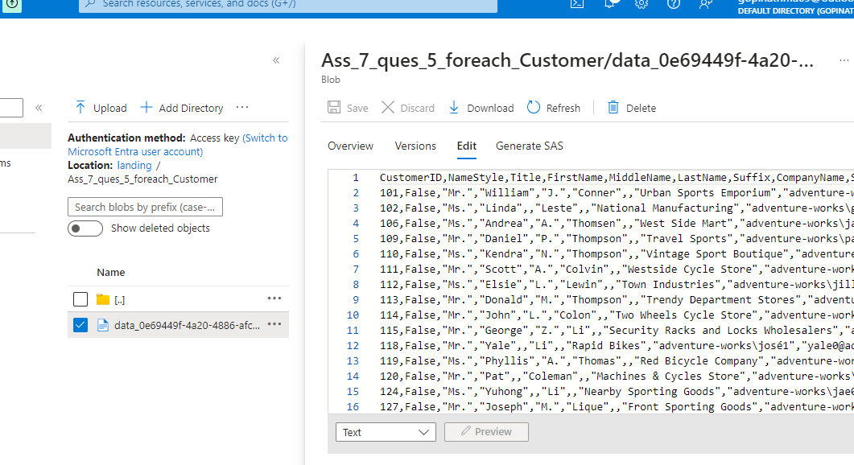

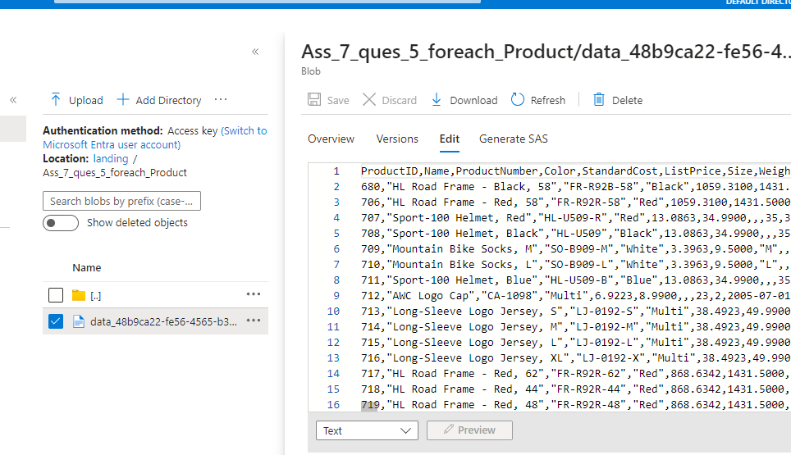

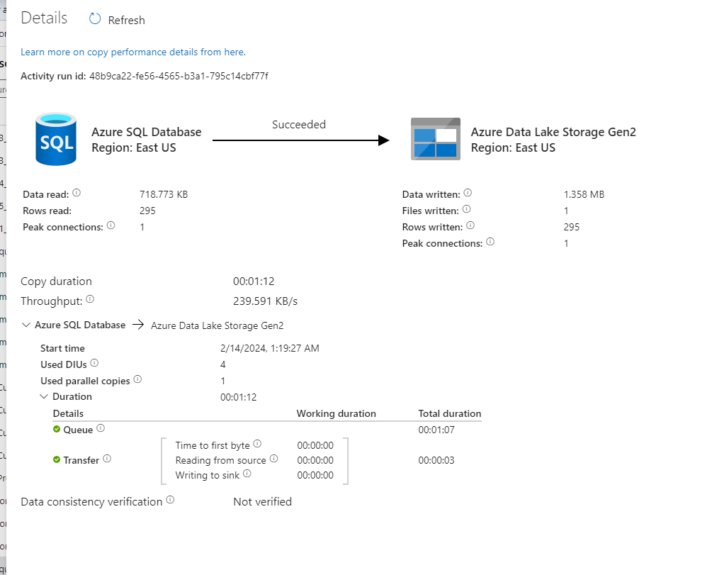

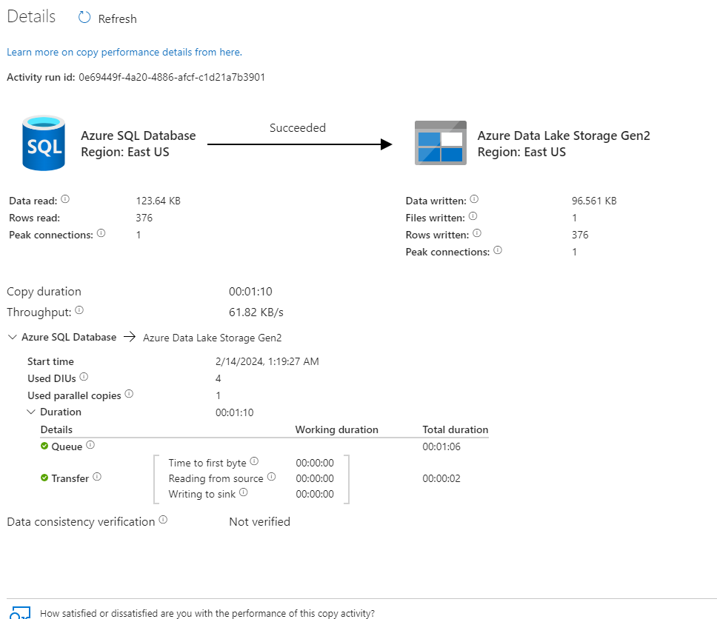

4. Create a pipeline that will create the incremental pipeline using
the table instead of HighWaterMark File.

Solution 4:

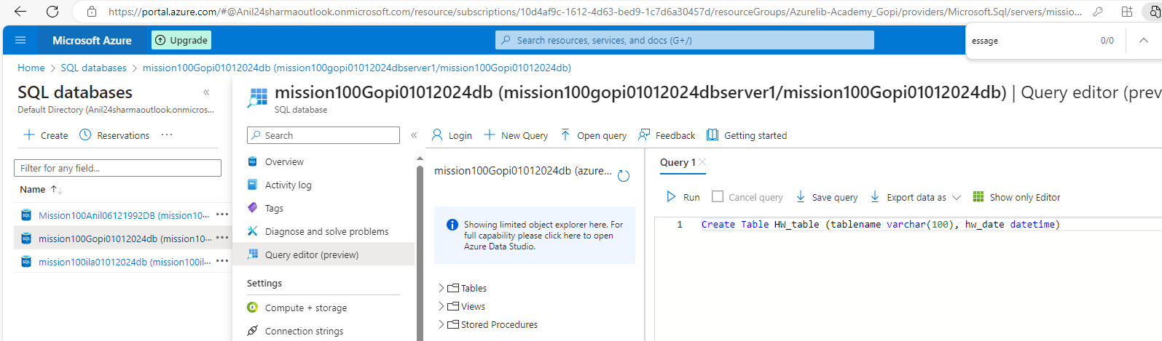

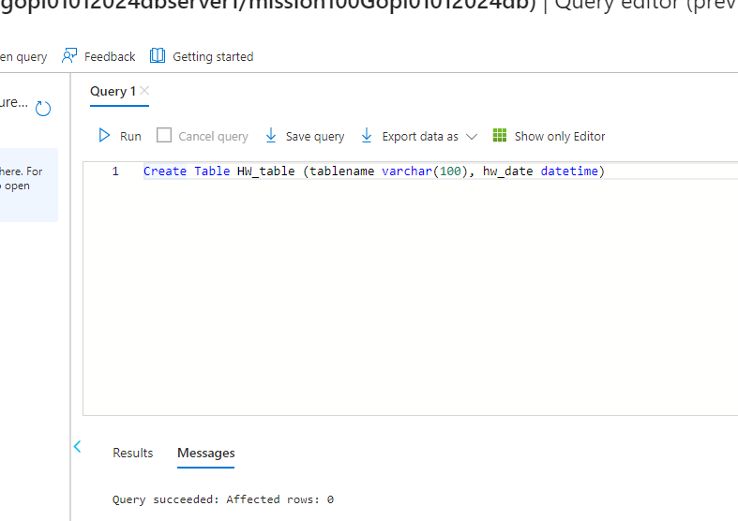

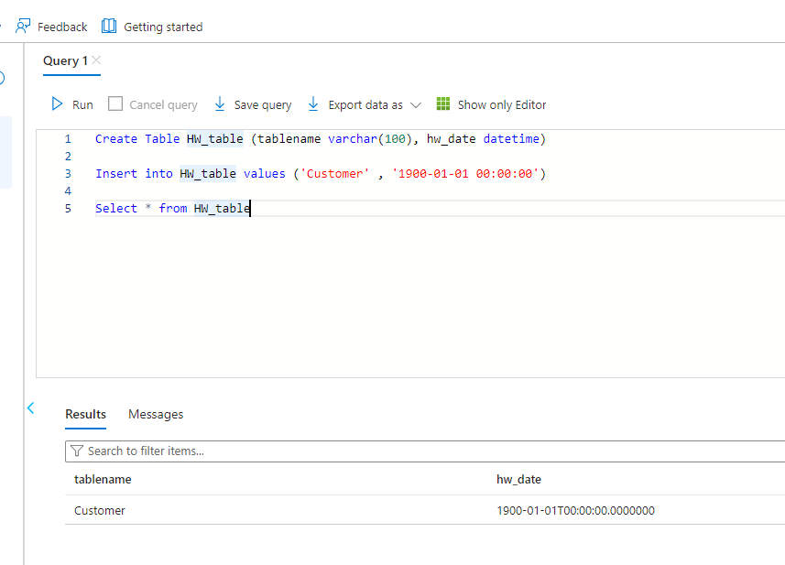

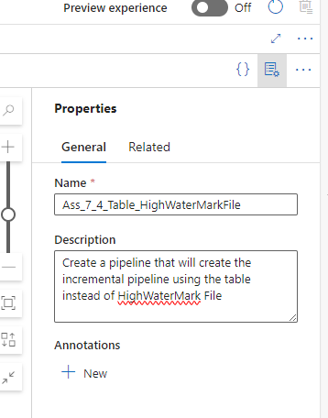

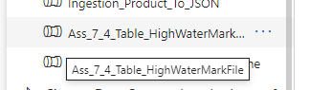

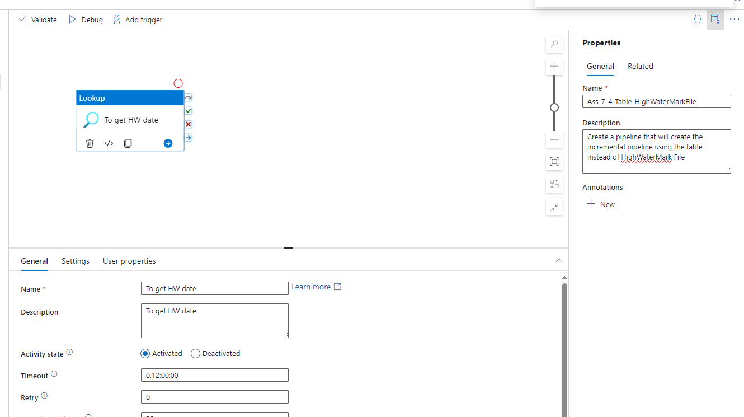

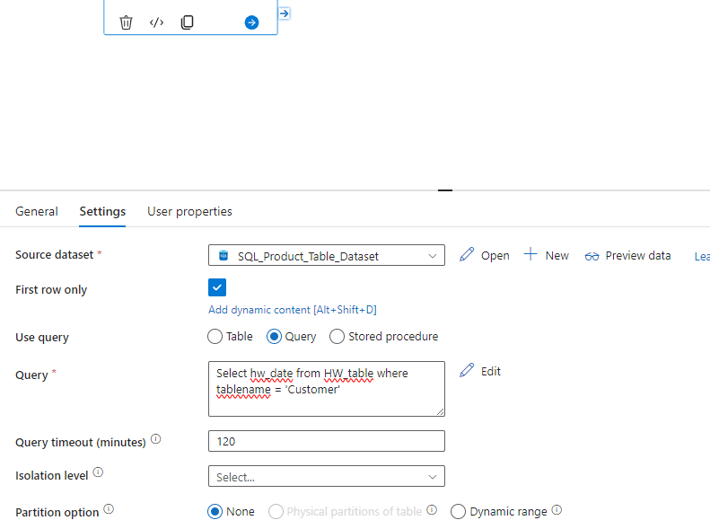

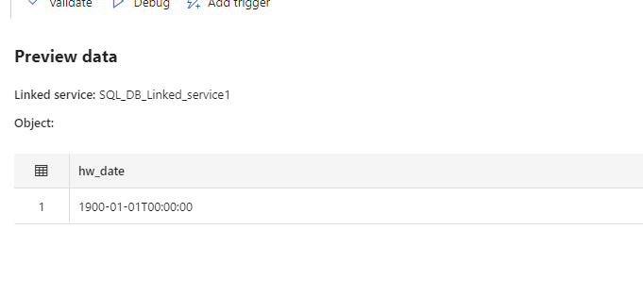

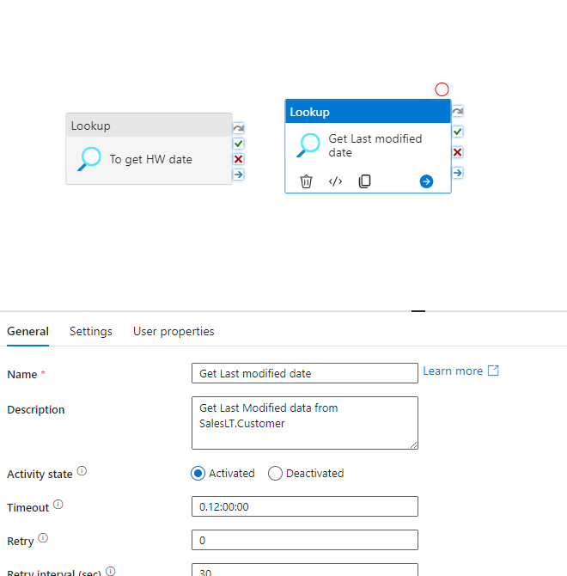

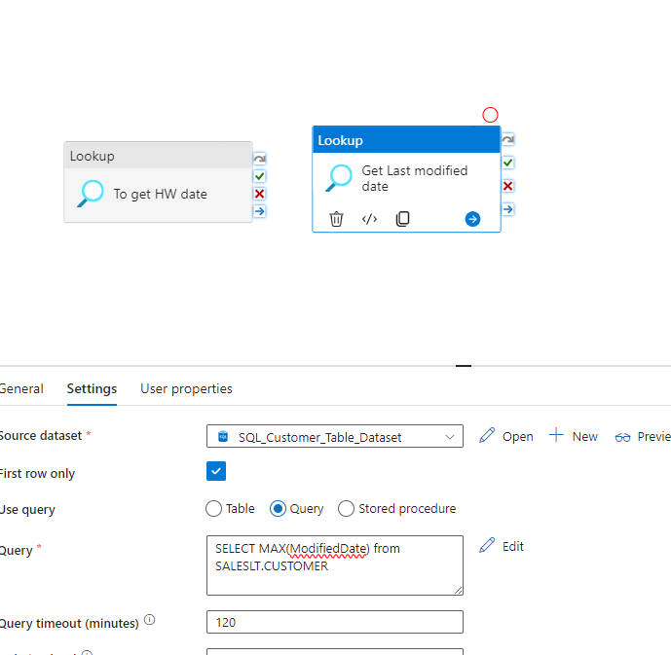

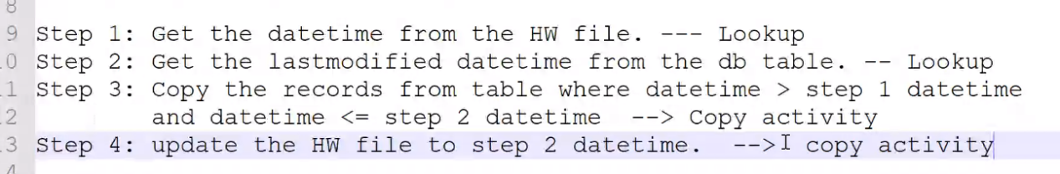

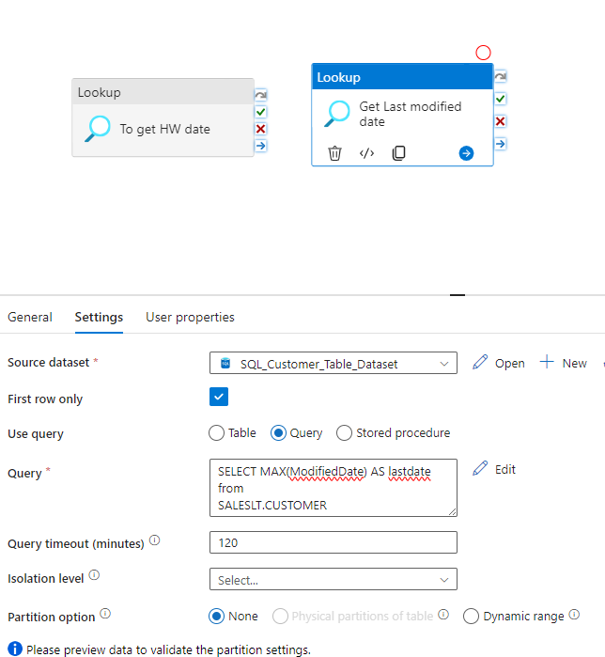
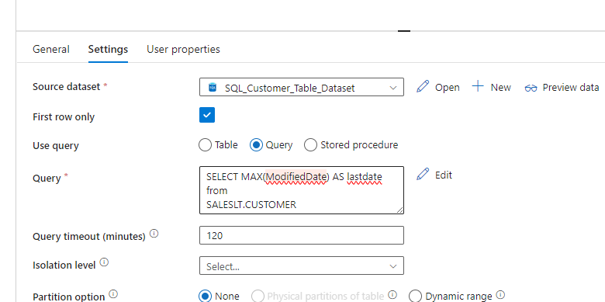
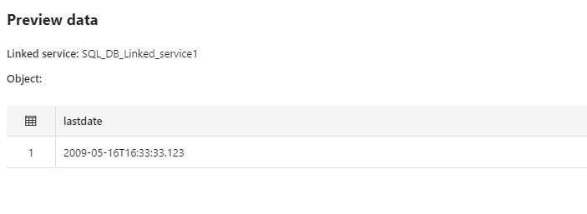

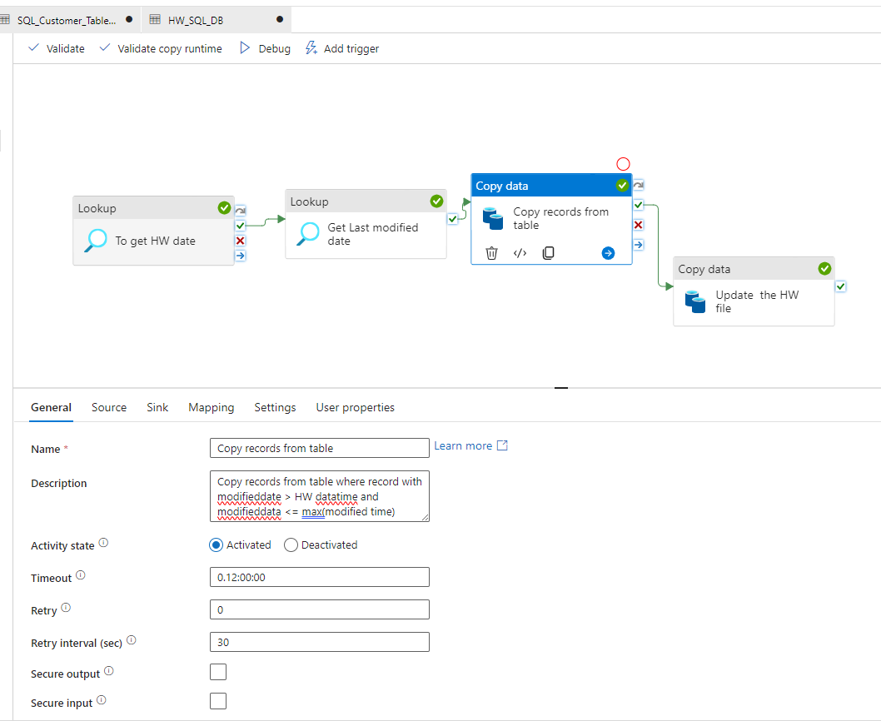

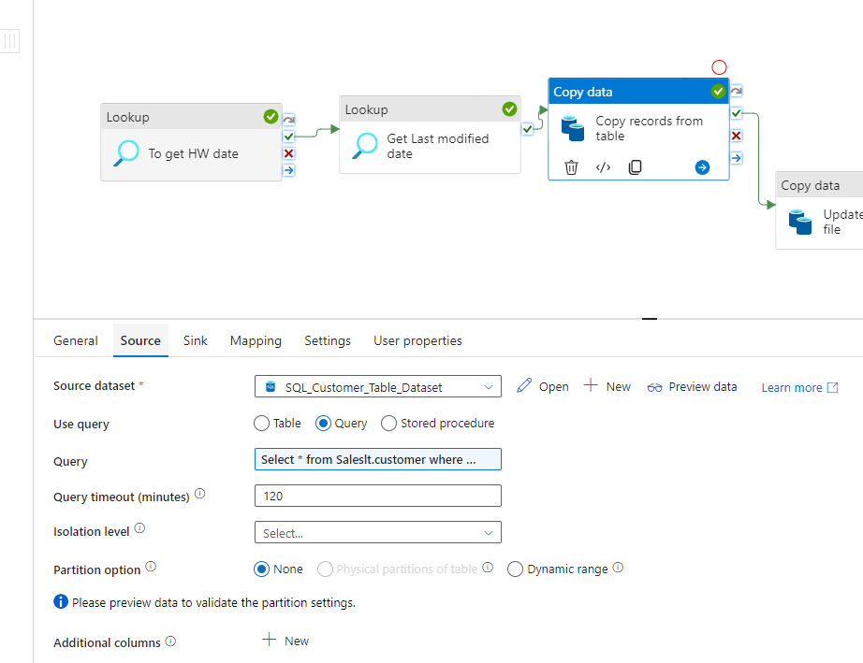

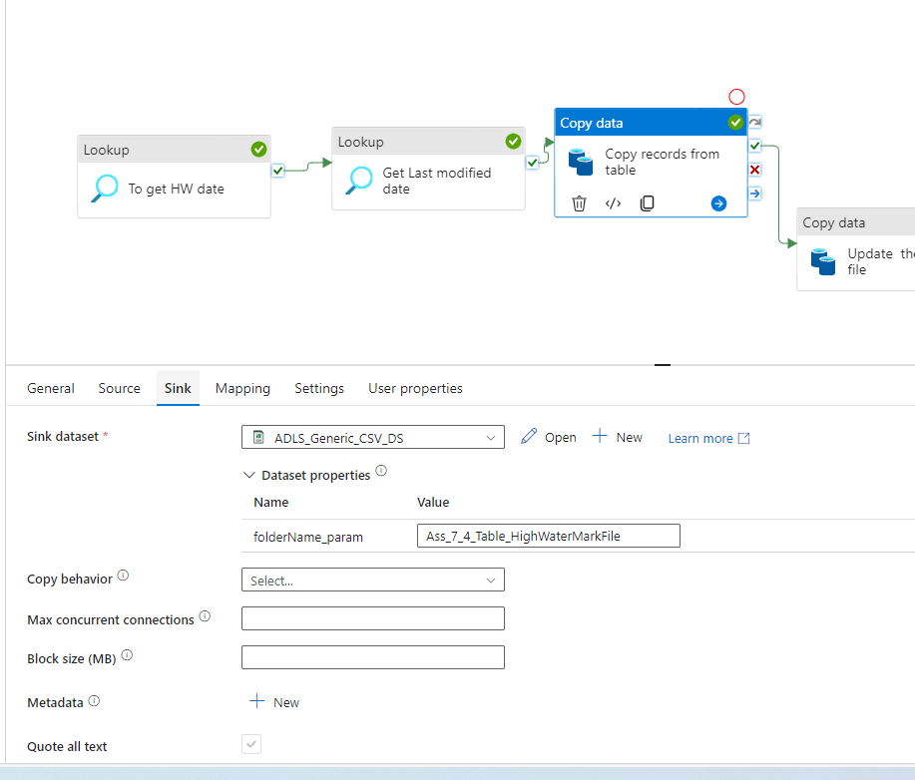

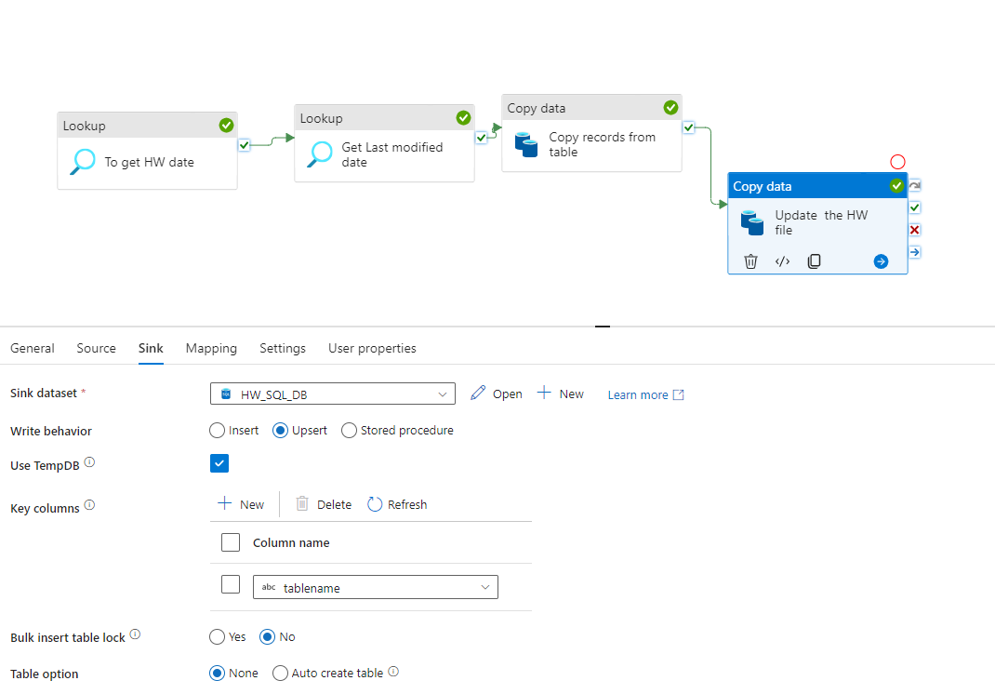

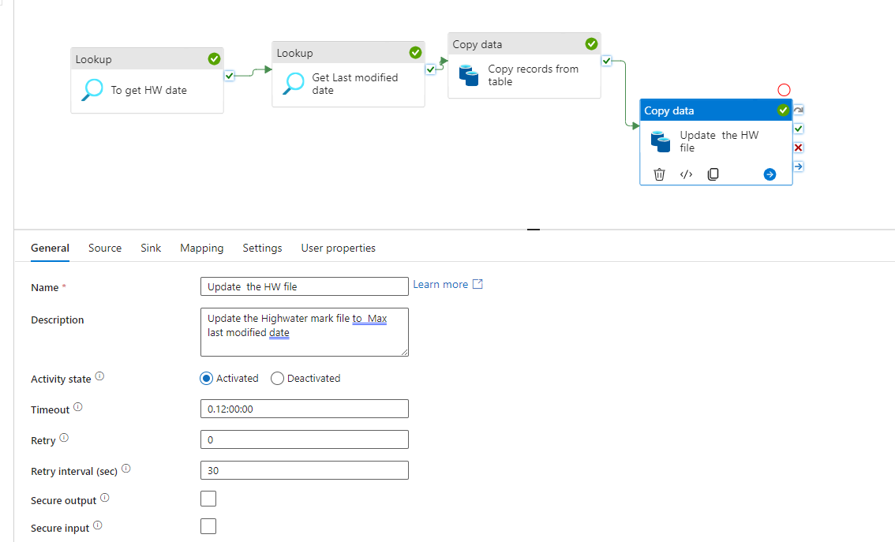

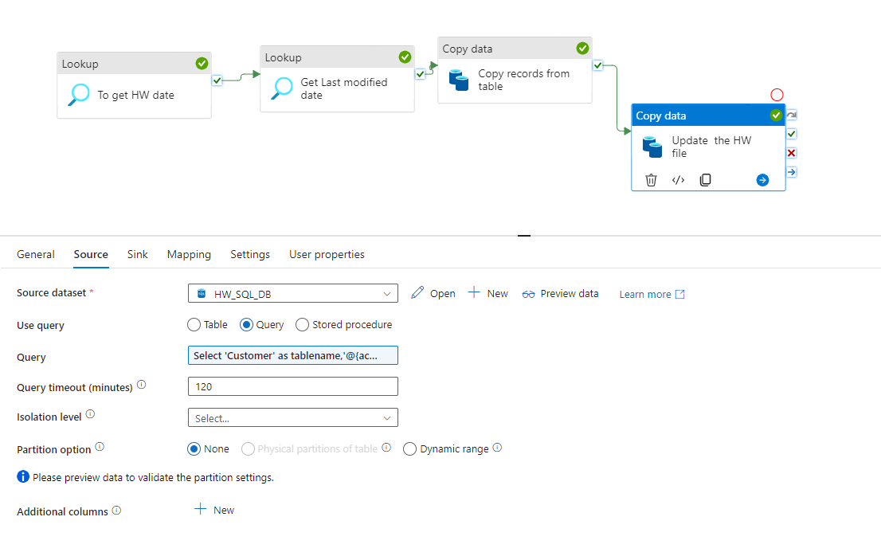

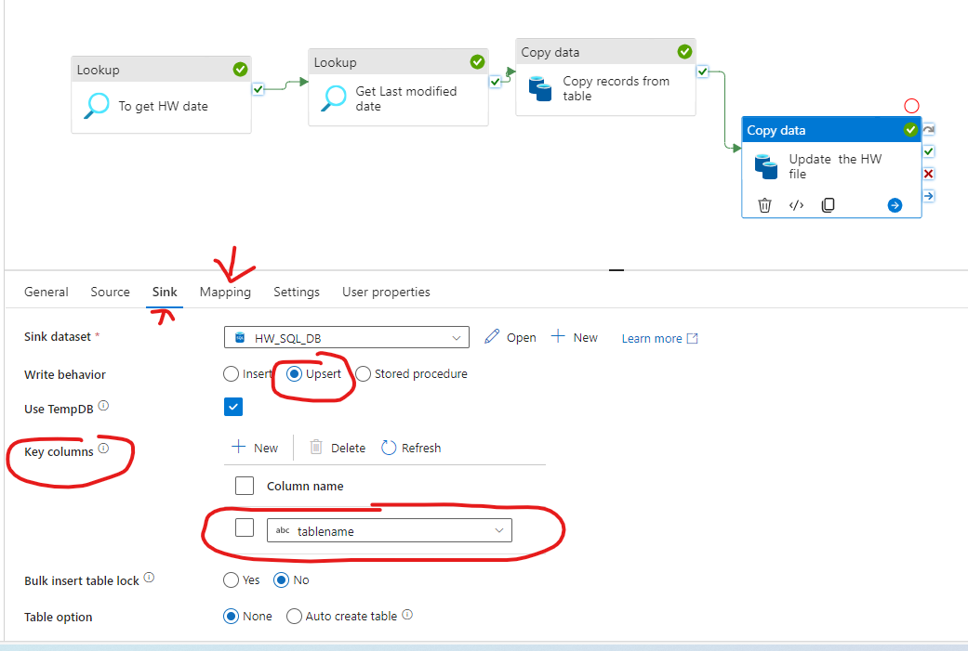

IF Select 'Customer' as tablename,'@{activity('Get Last modified date').output.firstRow.lastdate}' as hw_date

Output from above query is : tablename | hw_date

IF same tablename and hwdate from source and
Same tablename and hwdate in Sink exist, then instead of inserting, upsert
I,e update the values in HW sQL DB based on key column “

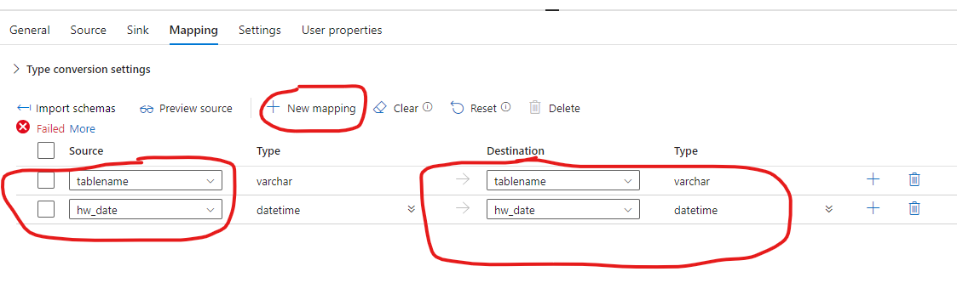

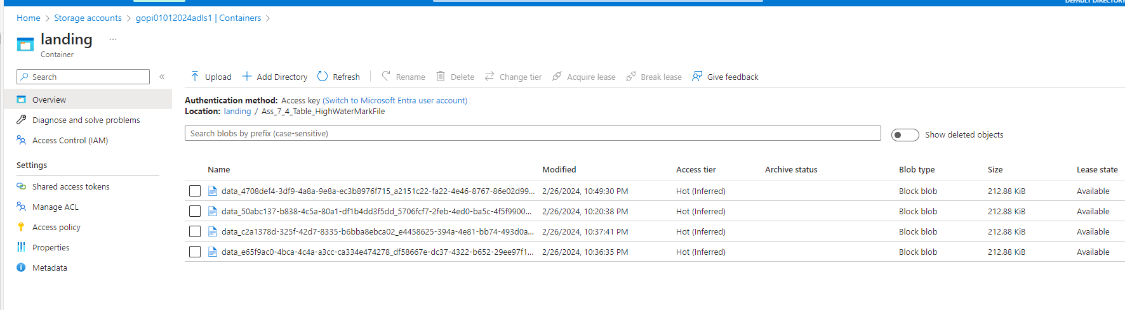

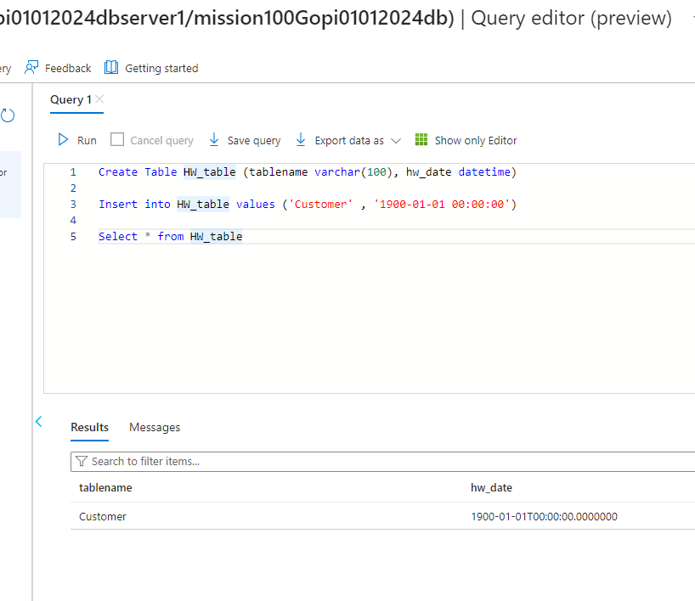

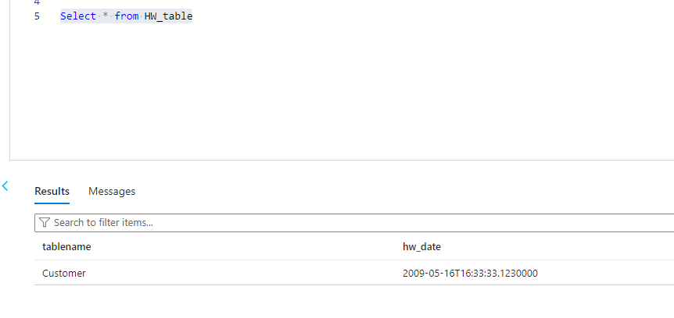

Final updated value in SQ DB table : “HW_table”

